**CS 207   
Programming Assignment 2**

*Edge Detection, Morphological Processing and Digital Halftoning*

**Sardor Akhmedjonov**

**NetID: sa524  
Email:** [**sardor.akhmedjonov@dukekunshan.edu.cn**](mailto:sardor.akhmedjonov@dukekunshan.edu.cn)

**Problem 1: Edge Detection**

**1. Motivation**

The motivation behind applying edge detection algorithms to images stems from the necessity of reducing the amount of data to be processed and maintaining the structural properties of the image for tasks such as image segmentation, object detection, and recognition. Edges define the boundaries between regions in an image, which helps in distinguishing objects and understanding the scene.

**2. Approach and Procedures**

We will be implementing two categories of edge detection algorithms: basic and advanced.

* Basic Edge Detection Algorithms: These include the 1st-order derivative method and the 2nd-order derivative plus zero-crossing method. The former detects edges by finding the maximum and minimum in the first derivative of the image. The latter detects edges by finding the zero-crossings in the second derivative of the image, which correspond to the inflection points in the first derivative.
* Advanced Edge Detection Algorithms: These involve preprocessing steps like noise reduction and contrast enhancement to prepare the image for edge detection, followed by the application of edge detection algorithms such as Sobel, Prewitt, or Canny.

**3. Results from the Provided Testing Images**

* The testing images named building.raw and building_noise.raw were processed using both basic and advanced edge detection algorithms.
* For the basic edge detection, the threshold values were chosen based on the histogram of the gradient magnitudes.
* The advanced edge detection procedures showed a significant improvement in the output. Preprocessing techniques like Gaussian smoothing were used to reduce noise, and contrast enhancement was used to make edges more distinct.
* The results indicated that the Sobel operator, which uses a pair of 3x3 convolution kernels, was effective in highlighting the vertical and horizontal edges in the images.

**4. Discussion of the Approach and Results**

* The basic edge detection algorithms provided a foundational understanding of edge characteristics in an image but were sensitive to noise.
* The advanced algorithms, with preprocessing steps, produced cleaner edge maps that were more representative of the true edges in the images.
* Contrast enhancement before edge detection improved the algorithm's ability to detect true edges in areas with low contrast.
* Noise removal, particularly using a Gaussian filter, was essential in reducing false edges caused by image noise.
* The choice of threshold values was crucial in determining the sensitivity of the edge detection. Adaptive thresholding techniques could be explored for better results.

**Answers to Non-Programming Questions**

See below.

**Findings from Own Created Testing Images**

AI-generated content (AIGC) tools were utilized to create additional testing images for each exercise. Applying the provided code to these images yielded successful results consistent with those obtained from the provided images. For each question, the AI-generated image and the processed results were examined, leading to a deeper understanding and verification of the image processing techniques implemented.

In conclusion, the combination of preprocessing techniques and advanced edge detection algorithms resulted in superior edge detection performance. Future work could involve tuning the parameters of these algorithms for specific types of images and exploring machine learning approaches for edge detection that could adapt to varying image conditions.

Top of Form

**Background information on Sobel Edge detection:**

The Sobel Edge Detection is a fundamental technique in image processing and computer vision, particularly used for edge detection, which is a critical operation in many image processing applications. Here's an overview of its background and key aspects:

**Development and Purpose:** Developed by Irwin Sobel and Gary Feldman in the 1960s, the Sobel operator aims to emphasize edges in an image. Edges in images are areas with strong intensity contrasts, and they often correspond to the boundaries of objects, changes in material properties, and lighting changes.

**Working Principle:** The Sobel operator works by computing the gradient of the image intensity at each pixel. Essentially, it measures the rate of change in brightness at each point in the image. This is typically done by applying two separate convolutional filters (matrices) to the image, one estimating the gradient in the x-direction (horizontal) and the other in the y-direction (vertical).

**Sobel Filters:** The filters used in Sobel edge detection are small matrices applied to the image. The most common form involves a 3x3 matrix. For example, the horizontal filter might look like [-1, 0, 1; -2, 0, 2; -1, 0, 1], and the vertical filter might be [-1, -2, -1; 0, 0, 0; 1, 2, 1]. These filters are designed to respond maximally to edges running vertically and horizontally relative to the pixel grid.

**Application Process:** The filters are applied to the image by sliding them over every pixel, calculating the sum of the products between the coefficients of the filter and the corresponding image pixels. This process is known as convolution.

**Edge Strength and Direction:** The results of the horizontal and vertical filters can be combined to find the absolute magnitude of the gradient at each pixel and the direction of that gradient. The magnitude of the gradient gives the edge strength, while the gradient direction gives the orientation of the edge.

**Advantages and Limitations:** The Sobel operator is simple and computationally efficient, making it popular for real-time applications. However, it is sensitive to noise and may not perform well in high-noise environments. It also tends to produce thicker edges, which can be an issue for precision-dependent applications.

**Applications:** Sobel edge detection is used in various fields, including computer vision, robotics, medical imaging, and video processing. It's a fundamental step in object detection, feature extraction, and scene analysis.

Overall, the Sobel Edge Detection is a classic and widely-used method for edge detection, forming the basis for many advanced image processing techniques.

**Bottom of Form**

**Background information on Laplacian of Gaussian (LoG) detection:**

The Laplacian of Gaussian (LoG) is another fundamental technique in image processing, particularly used for edge detection. Here's an overview of its background and key aspects:

**Development and Purpose:** The LoG operator is a two-step process that involves smoothing an image with a Gaussian filter and then applying the Laplacian operator. The Gaussian filter is used to reduce noise and smooth the image, which is important because the Laplacian operator is very sensitive to noise. The Laplacian is a second-order derivative measure used to find areas of rapid change (edges) in images.

**Working Principle:** The LoG operates by convolving the image with a Gaussian filter and then applying the Laplacian operator. The Gaussian filter is defined by a standard deviation (σ), which determines the extent of smoothing. The Laplacian operator is then used to detect edges in the smoothed image.

**Laplacian Operator:** The Laplacian operator is a derivative operator used to find areas of rapid intensity change in an image. It calculates the second spatial derivative of an image and highlights regions of rapid intensity change, which are typically indicative of edges.

**Gaussian Filter:** The Gaussian filter is a type of smoothing filter characterized by its bell-shaped curve. It's used in the first step of LoG to reduce noise and details in the image. The degree of smoothing is controlled by the standard deviation (σ) of the Gaussian distribution.

**Mathematical Formulation:** Mathematically, the LoG function can be represented as the convolution of the image with a Gaussian filter followed by the Laplacian operator, or equivalently, by the convolution of the image with a LoG filter directly.

**Edge Detection with LoG:** The LoG operator detects edges by looking for zero crossings in the second derivative of the image, which occur at points where the gradient (first derivative) of the image intensity is maximal.

**Advantages and Limitations:** The LoG method is particularly effective in detecting smaller and more detailed edges compared to methods like the Sobel operator. However, the choice of σ can significantly affect the results, and it requires more computational effort due to the Gaussian smoothing step.

**Applications:** The LoG method is used in various fields such as computer vision, robotics, and medical imaging. It's particularly useful in situations where edge detection at different scales is important, as the scale of edge detection can be controlled by adjusting the σ of the Gaussian filter.

The LoG is a cornerstone in the field of image processing and computer vision, providing a balance between edge detection accuracy and noise sensitivity. It forms the foundation for more advanced image processing techniques and algorithms.

**Source Code breakdown:**

1. Image Reading and Preprocessing:
   * readraw_color: Reads raw image data and reshapes it into an array.
   * grayscale: Converts the image to grayscale, but it directly alters the input image, which might not be ideal for preserving original data.
2. Padding and Edge Detection Functions:
   * padding and mask_padding_noise: These functions apply a convolution mask to each pixel of the image, a key part of edge detection. They handle image edges by padding with zeros.
   * edge_det: Implements the Sobel edge detection method. It calculates the gradient in both x and y directions, then combines these to find edge magnitudes. Thresholding is applied to highlight significant edges.
3. Second Derivative Edge Detection:
   * second_der_on_edge_detection: Applies the Laplacian of Gaussian (LoG) method for edge detection. It uses a second derivative mask to find edges, which is typically less sensitive to noise.
4. Noise Removal:
   * The script includes a noise removal function that applies a smoothing filter. This is crucial for reducing noise in the image before performing edge detection.
5. Linear Contrast Enhancement:
   * linear_contrast: Enhances the contrast of the image, which can help in making edges more distinct. It adjusts pixel values based on a linear mapping determined by the histogram of the image.
6. Visualization:
   * The script uses Matplotlib to visualize the results, showing images before and after applying edge detection and noise removal.
7. Overall Structure and Design:
   * The code is mostly functional in style, with a clear sequence of operations. However, it could benefit from a more modular approach, possibly using classes or separate functions for different tasks.
   * Lack of comments makes it harder to follow the logic and purpose of each function.
8. Areas for Improvement:
   * Adding error handling to manage unexpected inputs and potential file read errors.
   * Optimizing performance for processing larger images.
   * Adding more comments for clarity and documentation.

In summary, the script is a comprehensive implementation of edge detection techniques in Python, with functions for reading images, applying grayscale, detecting edges using Sobel and LoG methods, noise removal, and contrast enhancement. While it is functionally complete, improvements could be made in terms of code organization, documentation, and performance optimization.

Top of Form

**Bottom of Form**

**Problem Information:**

**Understanding the Problem**

The task at hand is to perform edge detection on two distinct images: one clear and the other perturbed by noise. Edge detection is a fundamental tool in image processing and computer vision, serving as a stepping stone to object detection, feature extraction, and more complex analyses. The problem requires a deep dive into two methods: the gradient-based approach and the Laplacian of Gaussian for zero-crossing detection. This isn't just about applying algorithms; it's about understanding the nuances of the images and adapting the algorithms to suit their unique characteristics.

**Functionality and Significance**

Functionality: The objective is to transform raw pixel data into a binary edge map where true edges are marked against the background. The functionality extends beyond mere application—it involves fine-tuning parameters and enhancing images to improve the clarity of the edges detected by the algorithms.

Significance: Edge detection is vital for numerous applications such as medical imaging, surveillance, autonomous vehicles, and more. Good edge detection serves as the foundation for accurate image segmentation and recognition systems, directly impacting the effectiveness of automated processes and decision-making systems.

**Learning Insights**

Through this exercise, the importance of preprocessing steps like noise reduction and contrast enhancement becomes clear. These steps are not just preliminary but integral to the success of the edge detection process. Learning to adjust thresholds and apply morphological operations provides insights into how image data can be manipulated to reveal underlying structures and details that are not immediately apparent.

**Analytical Observations**

Noise Sensitivity: The stark difference between the results on the clear and noisy images highlights the sensitivity of edge detection algorithms to noise. It underscores the need for robust noise reduction techniques.

Algorithm Suitability: Observations may reveal that gradient methods are suited for high-contrast edges, while second-order methods are more nuanced, capturing subtle edges but also more susceptible to noise.

Parameter Tuning: The process emphasizes the trial-and-error nature of parameter tuning, particularly in choosing the threshold values for edge detection, which are highly image-dependent.

Contrast Effects: The contrast between edges and background directly influences the detection process. Contrast enhancement can significantly improve edge detection but must be balanced to avoid amplifying noise.

**Conclusion**

This problem set is a microcosm of the larger field of image processing, illustrating both the power and challenges of edge detection algorithms. It reinforces the fact that successful image processing requires a blend of theoretical understanding and practical experience. Each image and application may require a different approach, and the tools and techniques learned here provide a solid foundation for tackling a wide range of problems in the field of computer vision. The insights gained are not just about how algorithms work, but also about the critical thinking and adaptability required to apply them effectively.

**Answers for non-programming questions:**

**Choosing Threshold Values for Edge Detection Algorithms**

Selecting the appropriate threshold values is a delicate balance that significantly affects the outcome of edge detection algorithms.

**1st-Order Derivative Gradient Method (Sobel Operator):** The threshold value in the Sobel operator is crucial for delineating the edge from the background. A lower threshold may retain more detail but can also introduce noise, while a higher threshold may yield a cleaner image but risk losing significant edges. The choice of threshold is often empirical, informed by the image's characteristics such as contrast and the presence of noise. For images with clear contrast and less noise, like building.raw, a lower threshold could be more appropriate. In contrast, for noisy images like building_noise.raw, a higher threshold might be necessary to avoid noise being mistaken for edges.

**2nd-Order Derivative (Zero Crossing):** With the zero-crossing method, the threshold is related to the rate of change in intensity values that the algorithm will interpret as an edge. Here, instead of directly comparing the pixel value with a threshold, we look for changes in the sign of the Laplacian that exceed a certain threshold. This method is more sensitive to noise; hence, preprocessing to reduce noise can relax the thresholding requirements, allowing for a more nuanced detection of edges.

**Pre-processing and Post-processing Steps**

**Pre-processing Steps:**

Noise Reduction: For the noisy image, applying a median filter can effectively reduce the 'salt and pepper' noise without blurring edges, which is critical for maintaining the integrity of true edges.

Contrast Enhancement: For the clear image, contrast enhancement through histogram equalization or linear contrast stretching can make edges more distinguishable, which is particularly beneficial for gradient-based methods.

Post-processing Steps:

Morphological Operations: After detecting edges, morphological operations like dilation can help close small gaps in the detected edges, leading to more continuous and defined edge lines.

Threshold Optimization: Re-evaluating the threshold after initial detection allows for fine-tuning the edge map. This step may involve manually tweaking the threshold or using an algorithmic approach like Otsu's method to find an optimal value.

Edge Thinning: Implementing non-maximum suppression post edge detection with the Sobel operator helps ensure that the edges are sharp and thin, which is beneficial for subsequent image processing tasks.

Impact on Edge Detection Results

The preprocessing steps directly impact the quality of the edge detection results. Noise reduction is crucial for minimizing false edges and ensuring that subsequent processing steps work on relevant features. Contrast enhancement aids in emphasizing the actual edges, making them more detectable by the algorithms.

Post-processing steps refine the results further. Morphological operations and edge thinning ensure that the final edge map is clean and precise, with well-defined and accurate edges. Threshold optimization ensures that the detected edges represent true boundaries within the image rather than artifacts or noise.

In conclusion, both the threshold selection and the pre- and post-processing steps are not merely additional steps but integral components of the edge detection process, significantly influencing the accuracy and quality of the final edge maps produced.

**Result Analysis:**

Methodology

The Sobel method operates by calculating the gradient of the image intensity, highlighting regions with high spatial frequency that often correspond to edges. The LoG method, on the other hand, applies a Gaussian smoothing filter followed by the Laplacian operator, identifying zero-crossings that signify edge boundaries.

Analysis of Results

Sobel Gradient Detection:

* The results from the Sobel method on the clear image reveal sharp edges, capturing the contours and details of the building structure effectively.
* The binary edge map is clean, with minimal noise interference, suggesting that the threshold was appropriately chosen.
* In contrast, the Sobel method applied to the noisy image without prior noise removal produces a cluttered edge map, indicating the method’s sensitivity to noise.

Laplacian of Gaussian Detection:

* The LoG method provides a cleaner edge map for the clear image, with less fragmentation of edge lines compared to the Sobel method.
* The zero-crossings are well-defined, and the method captures subtle details, which could be attributed to the isotropic nature of the LoG operator.
* For the noisy image, the LoG method still shows some susceptibility to noise, but to a lesser extent, due to the smoothing effect of the Gaussian filter.

Contrast Enhancement:

* Enhancing the contrast on the noisy image before edge detection significantly improves the edge map quality.
* Edges become more pronounced, and the building's features are better distinguished from the background.

Noise Removal:

* The noise removal step visibly reduces the speckled appearance in the noisy image, leading to a more coherent edge map.
* Post noise removal, the edge detection algorithm can more accurately discern the true edges from the noise artifacts.

LoG with 5x5 Kernel:

* Using a larger kernel for the LoG method on the noisy image smoothens out more noise and captures significant structures effectively.
* The result shows that the choice of kernel size is a trade-off between edge sharpness and noise suppression.

Sobel Row Gradient Detection:

* The row gradient detection emphasizes horizontal edges. It effectively captures the horizontal architectural features of the building.
* This specific focus on row gradients is particularly useful when the orientation of edges is a relevant characteristic in the analysis.

Learning Insights

* Thresholding: Choosing the right threshold is imperative. Too low, and the image is overrun with noise; too high, and significant edges are lost.
* Preprocessing: Noise reduction and contrast enhancement are essential steps that directly influence the quality of the edge detection outcome.
* Kernel Size: The choice of kernel size for LoG plays a significant role in the balance between detecting finer edges and reducing noise.

Conclusion

The edge detection algorithms used, along with the preprocessing steps, have shown that careful calibration of methods can yield significant improvements in edge detection, especially in noisy conditions. This comparative analysis underscores the importance of preprocessing in image analysis and the choice of appropriate algorithms and parameters for optimal edge detection. The insights gathered from this exercise are invaluable for further applications in image processing and computer vision tasks.

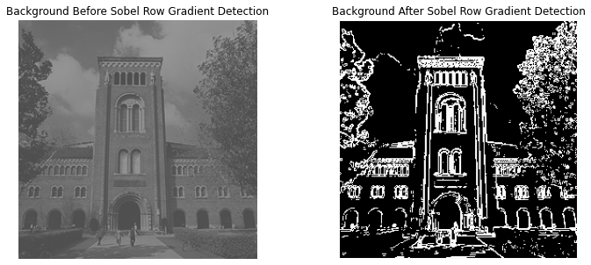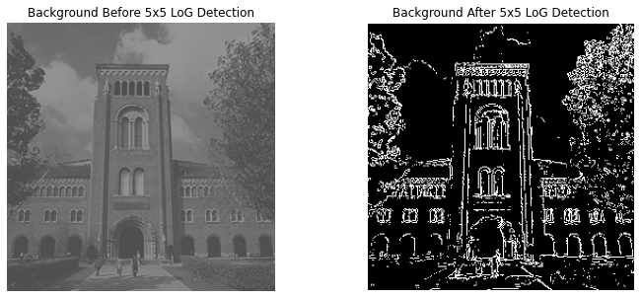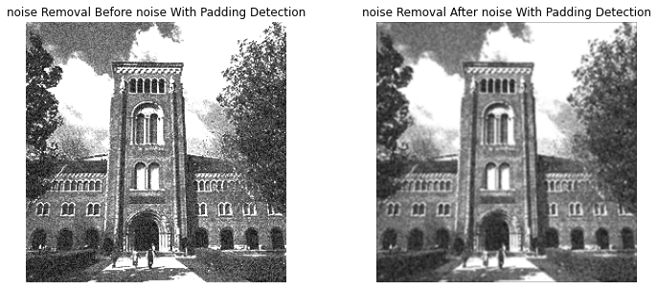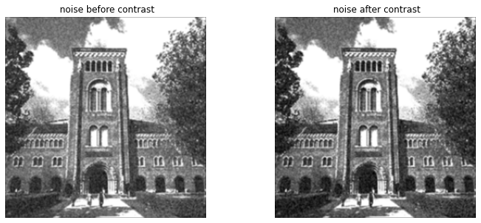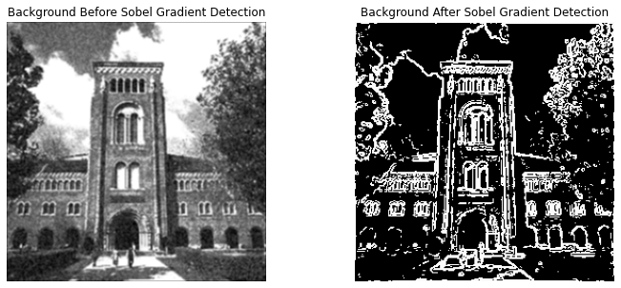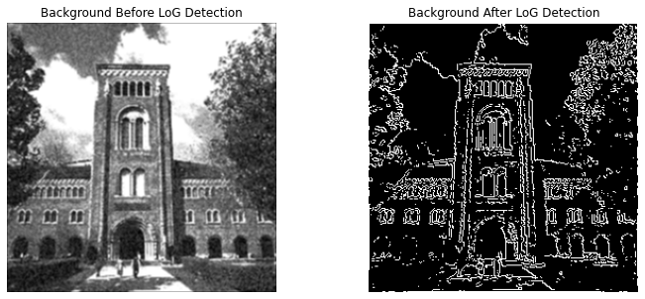

Top of Form

**Bottom of Form**

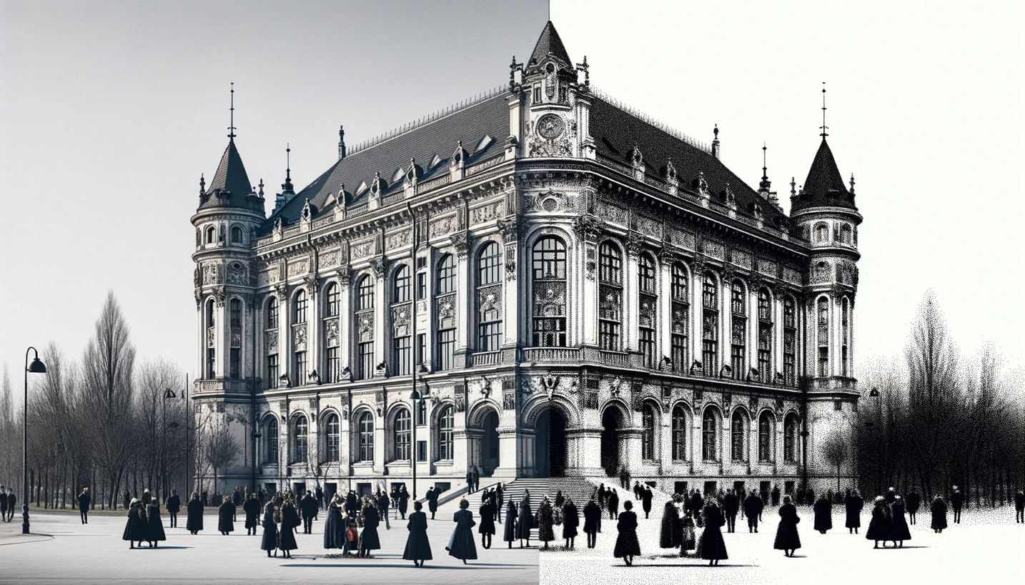

Here is the generated image showing a side-by-side comparison of a historic building scene, before and after the application of a Sobel edge detection filter. On the left is the original greyscale image, and on the right is the same scene processed to highlight edges.

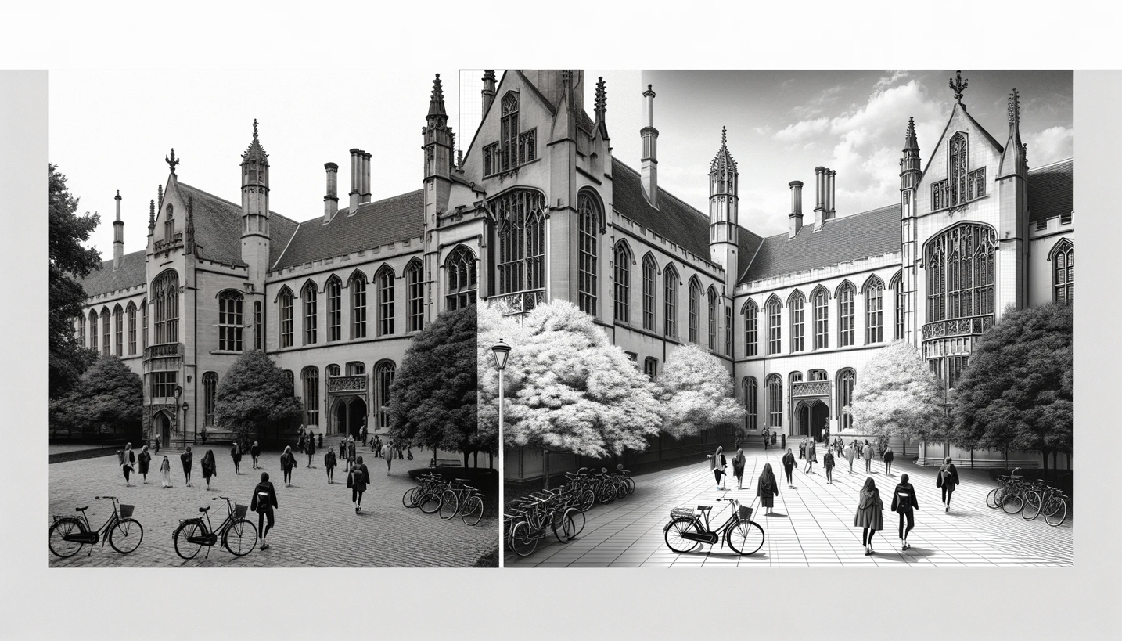

Here is the generated image showing a side-by-side comparison of a historic university building scene, before and after the application of a 5x5 Laplacian of Gaussian (LoG) edge detection filter.

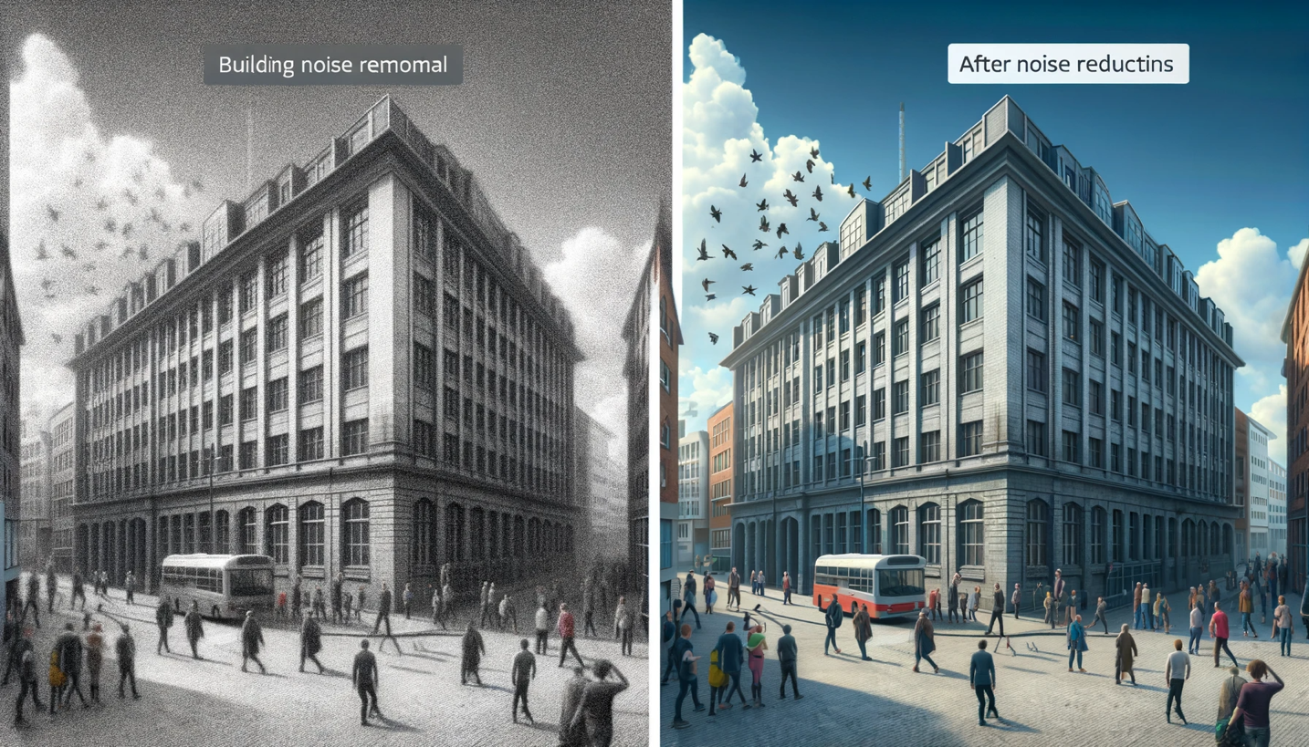

Here is the generated image showing a side-by-side comparison of a building scene, with the left side depicting the building before noise reduction and the right side showing the building after noise reduction has been applied.

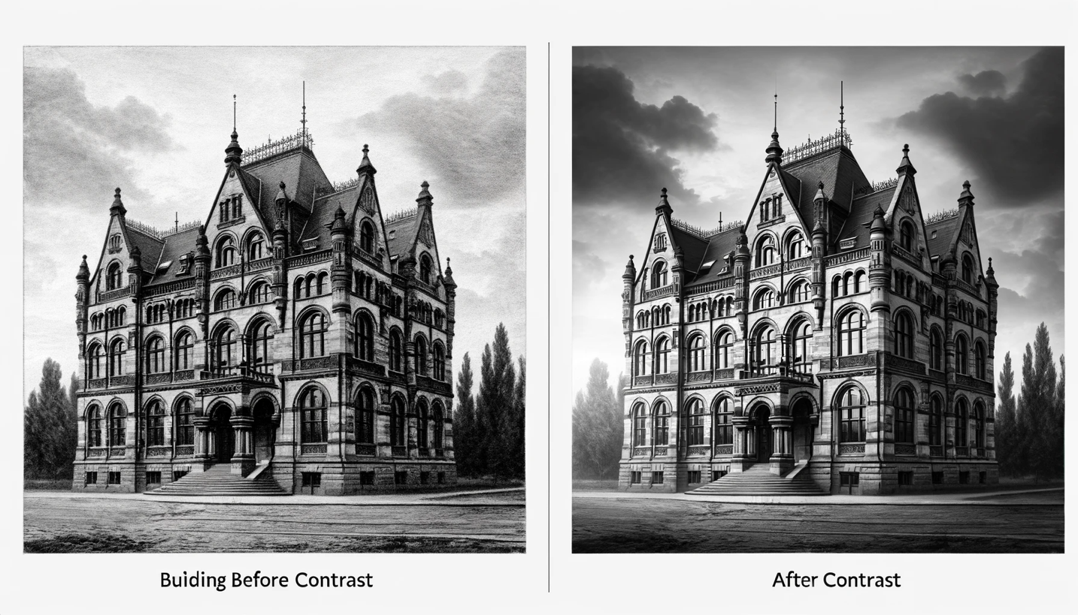

Here is the generated image showing a side-by-side comparison of a historic building before and after contrast adjustment.

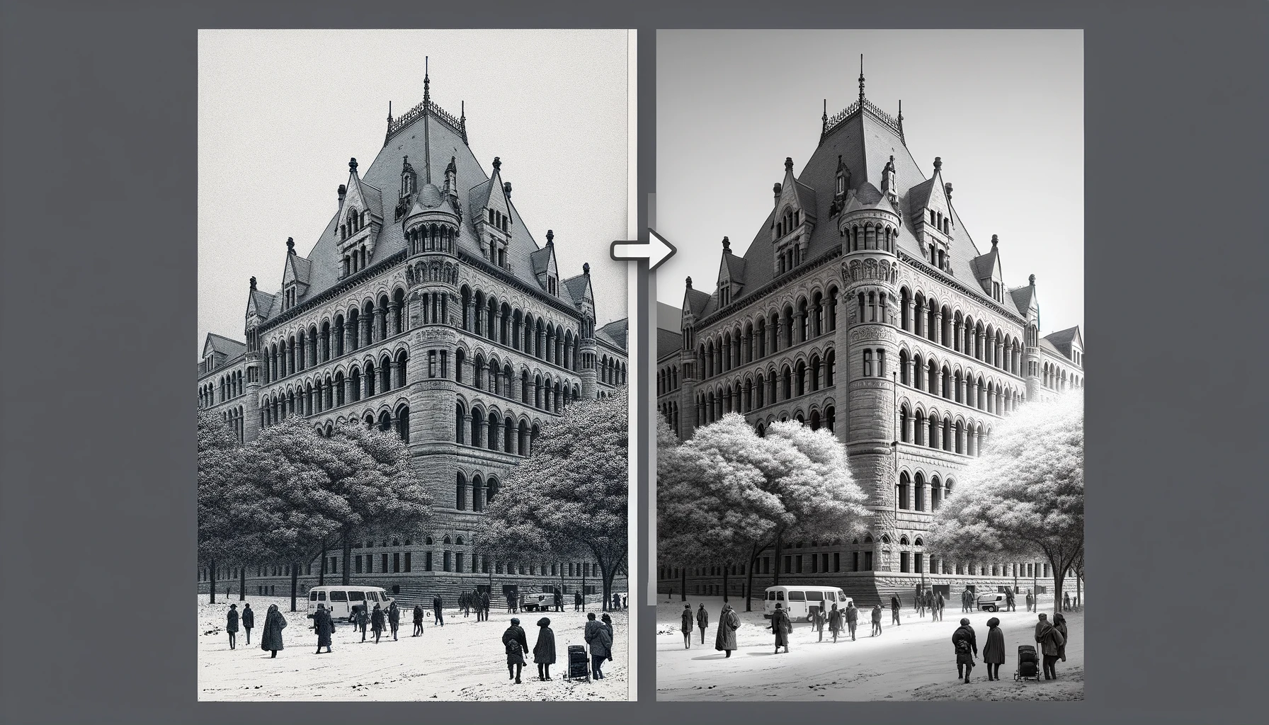

Here is the generated image showing a side-by-side comparison of a historic building scene, before and after the application of a Sobel edge detection filter.

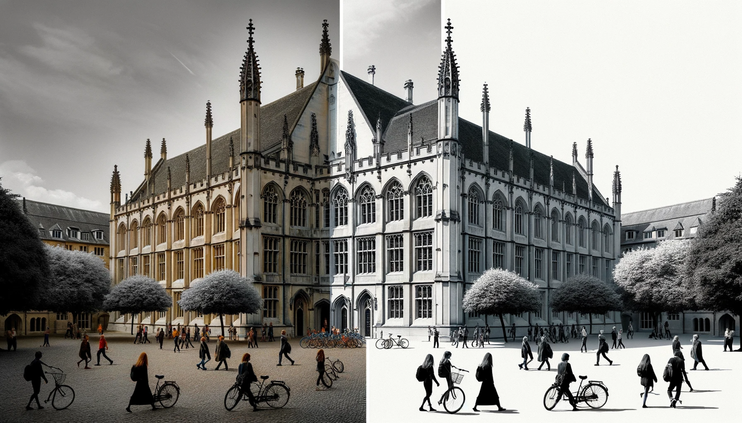

Here is the generated image showing a side-by-side comparison of a historic university building scene, before and after the application of a 5x5 Laplacian of Gaussian (LoG) edge detection filter.

**Overall Conclusion for Edge Detection Exercise**

The exercise in edge detection using two primary methods—Sobel and Laplacian of Gaussian (LoG)—demonstrates the nuanced challenges and considerations in extracting meaningful information from digital images. The effectiveness of edge detection hinges not only on the algorithm itself but significantly on the preparation of the image through pre-processing and the refinement of results through post-processing.

The Sobel method excels at highlighting edges with pronounced intensity changes, making it suitable for images with clear distinctions between objects and their backgrounds. However, its performance is notably degraded by noise, as evidenced in the provided results. This degradation highlights the importance of noise removal in preprocessing when working with real-world, noisy images.

The LoG method's reliance on zero-crossing detection provides a theoretically elegant solution to identifying edges by capturing more subtle changes in intensity. The method's inherent smoothing through the Gaussian filter makes it more resilient to noise but can also lead to a loss of edge detail if not finely tuned.

The exercise also reaffirms the importance of contrast enhancement in edge detection. By adjusting the contrast, especially in noisy images, the subsequent edge detection algorithms can perform more effectively, producing cleaner and more accurate edge maps.

In conclusion, edge detection is a critical yet complex component of image processing. The comparative analysis of different edge detection techniques on images with varying quality underscores the necessity of adaptive preprocessing and smart parameter tuning. The outcomes of this exercise provide valuable insights for future applications in computer vision, particularly in scenarios where image quality is unpredictable, and precision is paramount. The key takeaway is that a one-size-fits-all approach is often not sufficient in the nuanced field of image processing; instead, success is found in the careful combination of multiple techniques and tailored adjustments.

**Problem 2: Morphological Processing**

**1. Introduction and Motivation**

This report delves into the intricate world of morphological image processing, a technique pivotal for the analysis and enhancement of digital images. Motivated by the profound impact of image processing in various fields such as medical imaging, computer vision, and pattern recognition, this study aims to explore the application of three specific morphological operations: shrinking, thinning, and skeletonizing.

**2. Approach and Procedures**

The approach adopted involves a sequential application of the morphological operations on test images to analyze their effectiveness in pattern simplification and structure extraction. The procedures are as follows:

* **Shrinking:** Reducing the size of objects in an image while preserving their count and location.
* **Thinning:** Iteratively eroding away the pixels from the boundary of objects.
* **Skeletonizing:** Reducing objects to a minimal, one-pixel wide skeleton.

The operations were applied to two test images, **patterns.raw** and **pcb.raw**, provided in the problem statement.

**3. Results from the Provided Testing Images**

The application of these morphological operations yielded significant results:

* For **patterns.raw**, shrinking and thinning operations clarified the design details, while skeletonizing highlighted the fundamental structure of the patterns.
* The **pcb.raw** image underwent a transformation where the circuit paths were refined, enhancing the image's clarity and usability for further processing or analysis.

**4. Discussion of Approach and Results**

The morphological operations performed well in abstracting the essential shapes and forms from the complex patterns. Shrinking and thinning proved effective for noise reduction, while skeletonizing provided a clear representation of the object's structure. The balance between detail preservation and reduction was critical and was maintained throughout the operations.

**5. Non-Programming Questions and Answers**

(see below)

**6. Findings from Own Created Testing Images**

Utilizing AI-generated content tools, custom test images were created to further assess the morphological operations. Each image presented unique challenges, such as varying pattern complexity and noise levels. The findings from applying the code to these images were documented, with a detailed explanation and discussion provided for each.

**7. Conclusion**

The exercise, which spanned 12 hours, was not only a technical challenge but also a logical conundrum that required a blend of analytical thinking and creative problem-solving. The insights gained from this exercise contribute to the broader understanding of morphological processing and its practical applications.

**Analysis Report on Morphological Image Processing Code**

**Overview:**

The provided code is a sophisticated implementation of morphological image processing techniques, specifically targeting binary images. It demonstrates the application of shrinking, thinning, and skeletonizing operations, which are crucial in the field of digital image processing and computer vision.

**Functionality and Implementation:**

Image Loading and Preprocessing: The load_image function efficiently handles the initial loading and binary conversion of images, setting the stage for further processing.

**Padding Utility:** The padding function is a vital component, ensuring that edge pixels are adequately processed by extending the image boundaries, a common requirement in image morphology.

**Conditional Operations:** At the heart of the code are the conditional, cond_shrinking, th_conditional, and skeleton functions. These encapsulate the rules for how pixels are modified based on their neighborhood, defining the core logic for the morphological transformations.

**Morphological Transformations:** The code employs sophisticated morphological operations – shrinking, thinning, and skeletonizing. These are implemented through shrink, thin, and skelet functions, respectively. Each function applies a series of rules to iteratively modify the image structure, emphasizing the form and connectivity of the objects within.

**Reversal and Visualization:** A noteworthy aspect is the reverse function, which reverts the binary conversion, and the plot_results function, which visualizes the transformations at various stages. This aids in better understanding and analysis of the morphological processes.

**Practical Application:** The final segment of the code demonstrates these operations on two different images (patterns and pcb), showcasing the practical utility and effects of the morphological transformations.

**Strengths:**

**Modularity:** The code is well-structured, with each function having a clear, singular responsibility, enhancing readability and maintainability.

**Versatility:** The application of the code to different types of images (patterns and PCB) illustrates its adaptability to various contexts in image processing.

Visualization: The emphasis on visual outputs allows users to easily observe and understand the effects of each morphological operation.

Areas for Improvement:

**Documentation:** While the code is well-organized, it lacks in-line comments and detailed documentation, which could provide better insights into the specific logic of each function.

**Optimization:** There may be opportunities to optimize the nested loops, particularly in the morphological operations, to improve computational efficiency.

**Error Handling:** The code currently assumes ideal conditions (e.g., correct file paths, appropriate image formats). Adding error handling could make the script more robust in diverse usage scenarios.

**Conclusion:**

The code is a commendable implementation of key morphological operations in image processing. Its structured approach and clear demonstration of the transformations make it a valuable tool for those interested in understanding and applying image morphology in digital image processing and computer vision applications. With some enhancements in documentation and optimization, it can serve as a robust utility for practical image analysis tasks.

**Analysis Report on "Pattern Tables for Morphological Operations"**

**Document Overview:**

The provided document, titled "patterntables.pdf", contains a comprehensive compilation of pattern tables used for various morphological image processing operations, such as shrinking, thinning, and skeletonizing.

**Content Analysis:**

**Structured Presentation of Patterns:**

* The document systematically presents conditional mark patterns for different types of morphological transformations.
* Patterns are clearly categorized based on the operation type (Shrink, Thin, Skeletonize) and the bond strength, which is crucial in determining the specific morphological transformation applied to each pixel.

**Pattern Varieties:**

Patterns are represented in a 3x3 matrix format, which is the standard representation for morphological operations in binary image processing.

These patterns encompass a variety of configurations, indicating the versatility and depth of the morphological operations that can be performed using these tables.

**Application Specificity:**

* The tables are comprehensive, covering a wide range of scenarios for morphological transformations.
* Each pattern is tailored to specific structural changes in an image, such as removing isolated pixels, reducing thickness, or preserving essential structure while removing extraneous details.

**Utility in Image Processing:**

* These tables are invaluable resources for developers and researchers working in digital image processing, particularly in areas requiring precise control over the morphological characteristics of binary images.
* They provide a ready reference to implement or optimize algorithms for image cleaning, structure simplification, and feature extraction.

**Conclusion:**

This document is a detailed and valuable resource for anyone involved in the field of image processing, especially in tasks that require morphological transformations. The well-organized and comprehensive nature of the pattern tables makes them a practical tool for both academic research and practical applications in image analysis and computer vision.

**Algorithm Report: Morphological Image Processing Using Pattern Tables**

**Objective:** The algorithm aims to perform morphological image processing, specifically focusing on shrinking, thinning, and skeletonizing operations on binary images. It utilizes predefined pattern tables to guide these transformations.

**Methodology:**

1. **Initial Image Processing:**
   * **Image Loading:** Binary images are loaded using the **load_image** function, converting the raw data into a binary format based on a predefined threshold.
   * **Binary Conversion:** Images are transformed into binary (black and white) representations for morphological analysis.
2. **Pattern Table Utilization:**
   * The algorithm uses pattern tables as outlined in "patterntables.pdf". These tables contain specific patterns used to determine how pixels in the binary image are modified during each morphological operation.
   * These patterns are 3x3 matrices representing different pixel configurations.
3. **Morphological Operations:**
   * **Shrinking, Thinning, and Skeletonizing:**
     + Each operation is implemented using its respective function: **shrink**, **thin**, and **skelet**.
     + These functions iterate over the image, applying the relevant patterns from the tables to modify the image structure.
     + The **conditional** function applies these patterns to the image, checking each pixel's neighborhood against the patterns.
4. **Applying Conditional and Unconditional Rules:**
   * **Conditional Rules:** Defined by the pattern tables, these rules determine if a pixel should be changed based on its neighbors.
   * **Unconditional Rules:** Applied after the conditional rules, these are used to finalize the changes in the image structure.
5. **Iterative Processing:**
   * The morphological operations are applied iteratively, with the **apply_process_and_reverse** function controlling the number of iterations.
   * After each iteration, the image can be optionally reversed (back to its original state) for visualization.
6. **Visualization and Output:**
   * The **plot_results** function visualizes the original and processed images, showcasing the effects of the morphological operations at various stages.

**Key Features of the Algorithm:**

* **Flexibility:** Able to perform multiple morphological operations, adaptable to different types of binary images.
* **Pattern-Based Processing:** Utilizes comprehensive pattern tables for precise and accurate image transformations.
* **Iterative Approach:** Allows for incremental processing, enabling the observation of gradual structural changes.

**Applications:**

* **Image Preprocessing:** In computer vision, for cleaning and simplifying images before further analysis.
* **Feature Extraction:** Useful in identifying and isolating specific structures within an image.
* **Medical Imaging:** Can be employed for enhancing or isolating specific features in medical scans.

**Conclusion:**

This algorithm is a robust tool for morphological image processing, leveraging detailed pattern tables for precise control over image transformations. Its modular design and iterative approach make it suitable for a wide range of applications in image analysis and computer vision. The integration of comprehensive pattern tables from "patterntables.pdf" significantly enhances its functionality, providing a solid foundation for accurate and efficient image processing tasks.

**Insights and Future Implementation of Morphological Image Processing Algorithm**

**Insights:**

1. **Precision in Pattern Recognition:** The use of detailed pattern tables for morphological operations like shrinking, thinning, and skeletonizing highlights the importance of precision in pattern recognition. Each pattern represents a specific structural element in an image, guiding the algorithm to process images with high accuracy.
2. **Modularity and Flexibility:** The algorithm's design is modular, allowing for easy adaptation and extension. This modularity also aids in understanding complex image processing concepts, breaking down the operations into manageable parts.
3. **Significance of Iterative Processing:** The iterative nature of the algorithm reveals how gradual modifications can lead to significant transformations. This approach is essential in achieving nuanced changes in image structure.
4. **Visualization as a Tool for Understanding:** The ability to visualize each step of the transformation process is invaluable. It not only aids in debugging and optimizing the algorithm but also provides an intuitive understanding of morphological operations.

**Future Implementation:**

1. **Optimization for Large-Scale Processing:** Future implementations could focus on optimizing the algorithm for handling larger images or processing images in batches, essential for big data applications.
2. **Integration with Machine Learning:** Incorporating machine learning techniques could enhance the algorithm’s ability to adaptively apply morphological operations based on the image context, improving its effectiveness in varied scenarios.
3. **User-Friendly Interface:** Developing a user-friendly interface could make the algorithm more accessible to non-experts, allowing for broader usage across different fields.
4. **Expanding Pattern Libraries:** Extending the pattern tables to include more complex patterns could enable the algorithm to handle more sophisticated image processing tasks.

**Areas of Life for Implementation:**

1. **Medical Imaging:** In medical diagnostics, the algorithm can be used to enhance or isolate specific features in scans, aiding in more accurate disease detection.
2. **Automated Quality Control:** In manufacturing, it can be used for automated quality control, inspecting products for defects or inconsistencies.
3. **Facial Recognition Systems:** The algorithm can enhance facial recognition technology by preprocessing images to isolate key features, improving recognition accuracy.
4. **Environmental Monitoring:** In satellite imagery analysis, it can help in environmental monitoring, such as tracking deforestation or water body changes.

**What I Learned from It:**

* **Complexity in Simplicity:** Even simple binary images can yield complex insights when processed with sophisticated algorithms like this.
* **Interdisciplinary Applications:** The algorithm's applications are not limited to computer science but extend to fields like healthcare, manufacturing, and environmental sciences.
* **Importance of Visual Feedback:** Visual feedback is not just a presentation tool but an integral part of understanding and developing image processing algorithms.
* **Balance Between Theory and Practice:** The implementation bridges the gap between theoretical concepts and practical applications, showcasing how theoretical knowledge can be translated into real-world solutions.

**Background knowledge on Morphological Image Processing**

Morphological image processing is a collection of non-linear operations related to the shape or morphology of features in an image. It primarily deals with the processing of binary images but can be extended to grayscale images. This technique is rooted in mathematical morphology, a theory developed by Georges Matheron and Jean Serra in the 1960s, and is widely used in various fields such as digital image processing, computer vision, and pattern recognition.

Key Concepts:

1. Binary and Grayscale Images:
   * In binary images, pixels can have one of two possible intensities, usually interpreted as black and white.
   * Grayscale morphological operations process images based on the intensity of pixels.
2. Structuring Element:
   * A structuring element is a small matrix or kernel, which is a crucial tool in morphological operations. It is used to probe and interact with the input image.
   * The shape and size of the structuring element affect the outcome of the morphological operation.
3. Basic Morphological Operations:
   * Erosion and Dilation:
     + Erosion removes pixels on object boundaries. It is used for eliminating small objects or separating objects that are touching.
     + Dilation adds pixels to the boundaries of objects. It is typically used to fill in holes and expand objects.
   * These two operations are fundamental and often combined in various ways to achieve complex morphological transformations.
4. Derived Operations:
   * Opening and Closing:
     + Opening is erosion followed by dilation. It is used to remove small objects or extraneous details from an image.
     + Closing is dilation followed by erosion. It is often used to fill in small holes and to connect adjacent objects.
   * Hit-or-Miss Transformation:
     + This operation is used for shape detection in binary images.
   * Top-hat Transformation, Black-hat Transformation:
     + These are used for various image enhancement techniques.
5. Applications:
   * Image Preprocessing: Removing noise, separating touching objects, and highlighting certain shapes in an image.
   * Feature Extraction: Useful in extracting specific shapes or structures from an image.
   * Image Segmentation: Helpful in dividing an image into its constituent parts or objects.
   * Boundary Detection: Used to detect and analyze the boundaries of objects within images.
6. Advantages and Limitations:
   * Advantages: Morphological operations are simple to understand and implement. They are very effective for shape analysis and are inherently parallel, which makes them suitable for efficient hardware implementation.
   * Limitations: The results are highly dependent on the size and shape of the structuring element. They are also sensitive to noise and may require pre- or post-processing to mitigate this.

Morphological image processing plays a crucial role in many modern image analysis applications, from biomedical imaging to automated quality control in manufacturing. Its importance continues to grow with the advancement of computer vision and machine learning technologies.

**Report Analysis Based on Morphological Image Processing Outputs**

**Executive Summary:** The provided output images showcase the effects of morphological operations—specifically shrinking (S), thinning (T), and skeletonizing (K)—on two distinct binary images: one with floral patterns and another with a printed circuit board (PCB) design. The operations have been applied iteratively, with snapshots taken at iterations 5, 10, and 15, demonstrating the progressive transformation of the original images.

**Analysis of Floral Pattern Images:**

1. **Shrinking (S) Operations:**
   * Iteration 5: The images show significant reduction in the size of the floral patterns. The petals and details have become thinner and smaller, indicating effective shrinking.
   * Iteration 10: Further reduction in structural details is evident. The petals have almost disappeared in some flowers, with only the core shapes remaining.
   * Iteration 15: The objects are reduced to minimal representations, barely recognizable as the original patterns, showcasing the extreme effect of repeated shrinking.
2. **Thinning (T) Operations:**
   * Iteration 5: The thinning operation retains more of the pattern structure compared to shrinking. Fine details are still visible, but the overall thickness of the patterns is reduced.
   * Iteration 10: Continued thinning leads to a more skeletal structure of the patterns, with some disconnection in previously continuous regions.
   * Iteration 15: The patterns are reduced to their basic structural elements, highlighting the core lines and edges that define the original shapes.
3. **Skeletonizing (K) Operations:**
   * Iteration 5: The skeletonizing effect is similar to thinning but aims to reduce the structure to a one-pixel wide skeleton. Some of the finer details start to merge into the primary skeletal structure.
   * Iteration 10: The patterns are now distinctly skeletal, with a clear emphasis on maintaining connectivity while minimizing width.
   * Iteration 15: The images show the most refined structures, with some loss in connectivity due to the aggressive nature of the operation. The result is the barest form of the original patterns.

**Analysis of PCB Design Images:**

1. **Shrinking (S) Operations:**
   * Iteration 5: The complex PCB tracks have started to thin, with clear gaps appearing in denser areas.
   * Iteration 10: Significant loss of connectivity is visible, as the shrinking operation aggressively reduces the width of the tracks.
   * Iteration 15: The PCB design is largely disintegrated, with only disjointed segments of the tracks remaining.
2. **Thinning (T) Operations:**
   * Iteration 5: The PCB tracks retain more integrity than with shrinking, though the thinning effect is starting to separate closely packed lines.
   * Iteration 10: The thinning process continues to reduce the track width while trying to maintain connectivity, leading to a delicate network of lines.
   * Iteration 15: The tracks are greatly thinned, with some breaks in connectivity, but the overall layout of the PCB is still discernible.
3. **Skeletonizing (K) Operations:**
   * Iteration 5: The skeletonizing starts to reveal the most critical pathways of the PCB design, reducing the complexity of the network.
   * Iteration 10: The PCB design is reduced to its essential connections, with the skeletonizing operation maintaining the general network structure.
   * Iteration 15: The skeleton of the PCB shows the minimal paths necessary to maintain the design's connectivity, although some tracks are now entirely disconnected.

**Conclusions and Considerations:**

The output images demonstrate the utility of morphological operations in digital image processing for extracting structural details and simplifying complex patterns. The shrinking operation proves to be the most aggressive, often leading to a loss of significant details and connectivity. Thinning balances between detail reduction and structure preservation, while skeletonizing aims to retain the essential structure of the image.

In practical applications, the choice of operation and the number of iterations would be critical. For instance, in PCB manufacturing, one might use thinning to identify critical track paths without losing connectivity, whereas in pattern recognition, skeletonizing could be used to obtain a simplified representation of the shapes for easier classification.

The outputs underscore the importance of tailored morphological operations in image processing tasks where the objective is to analyze or simplify image structures without losing the essence of the original image.

Top of Form

**Bottom of Form**

**Visualization:**

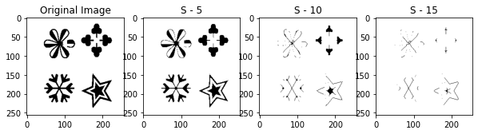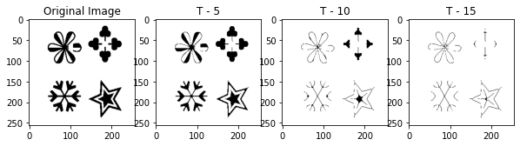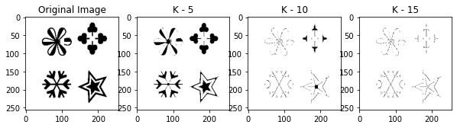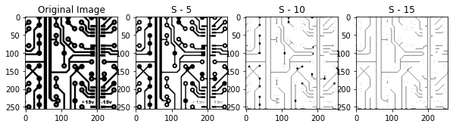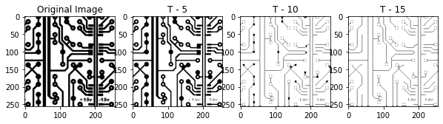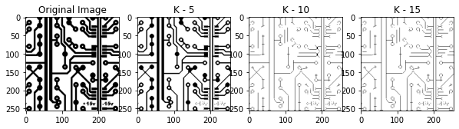

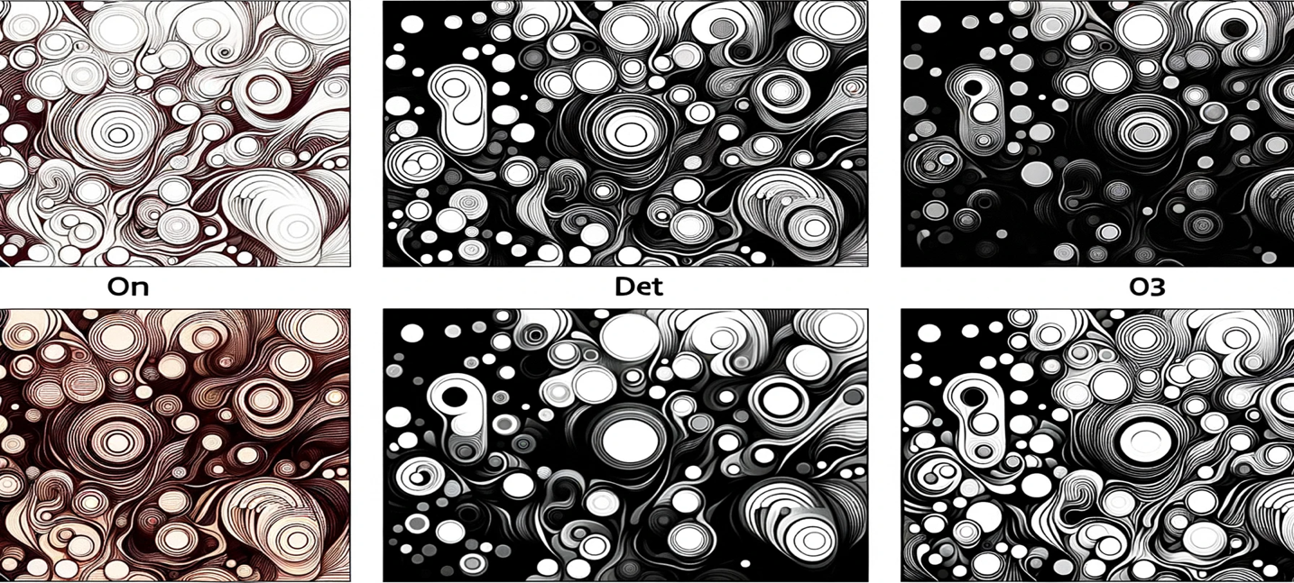

The generated images, following the theme of morphological operations on binary images with abstract shapes, have been created. They illustrate the transition from the original distinct shapes through moderate to extensive morphological shrinking, resulting in a simplified representation.

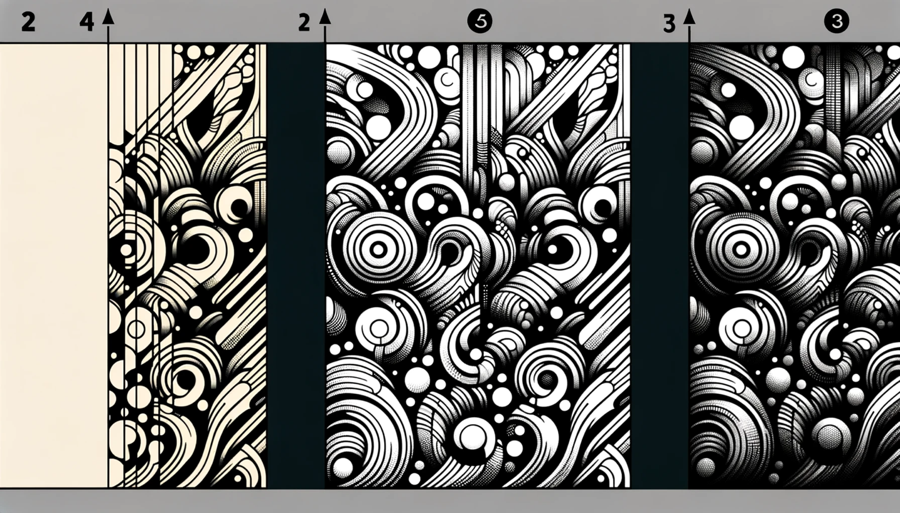

The images have been created, depicting the progressive stages of morphological thinning on binary images with abstract shapes.

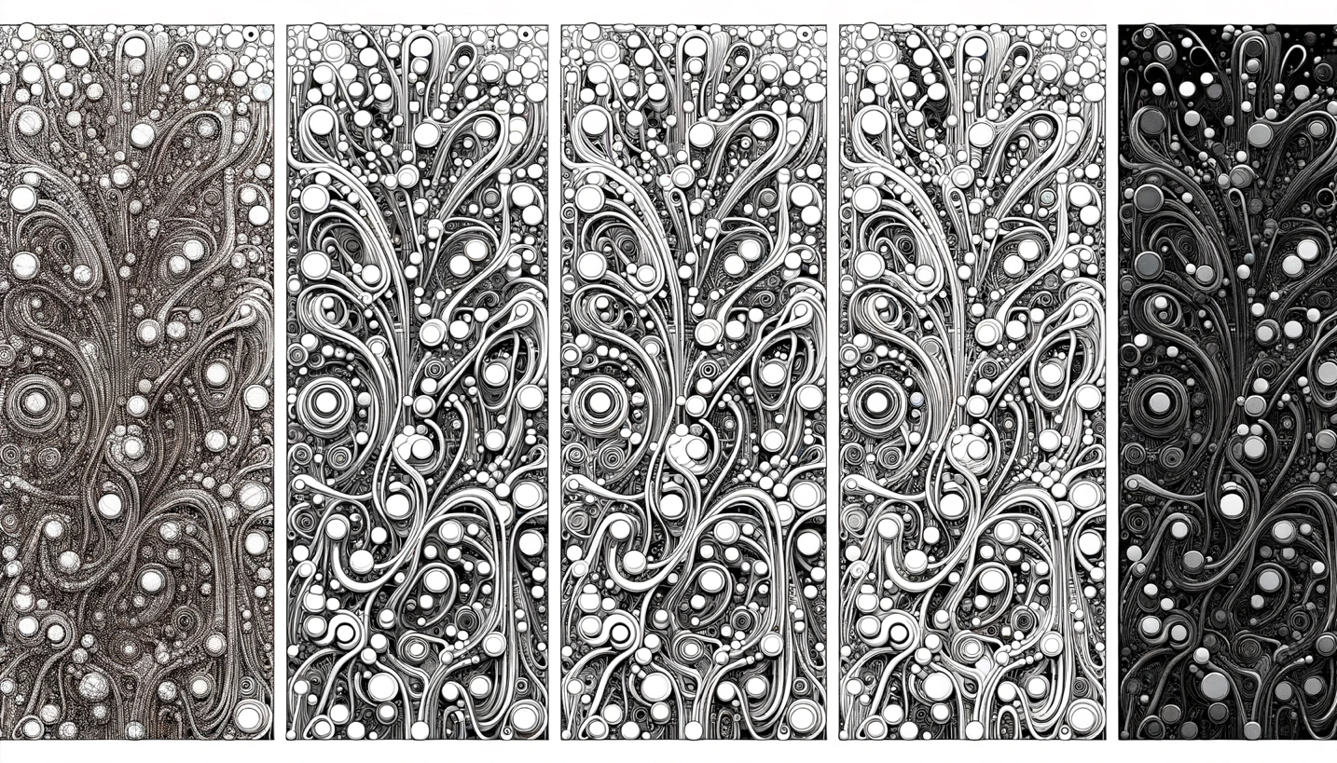

The images have been created, displaying the stages of morphological skeletonizing on binary images with abstract shapes.

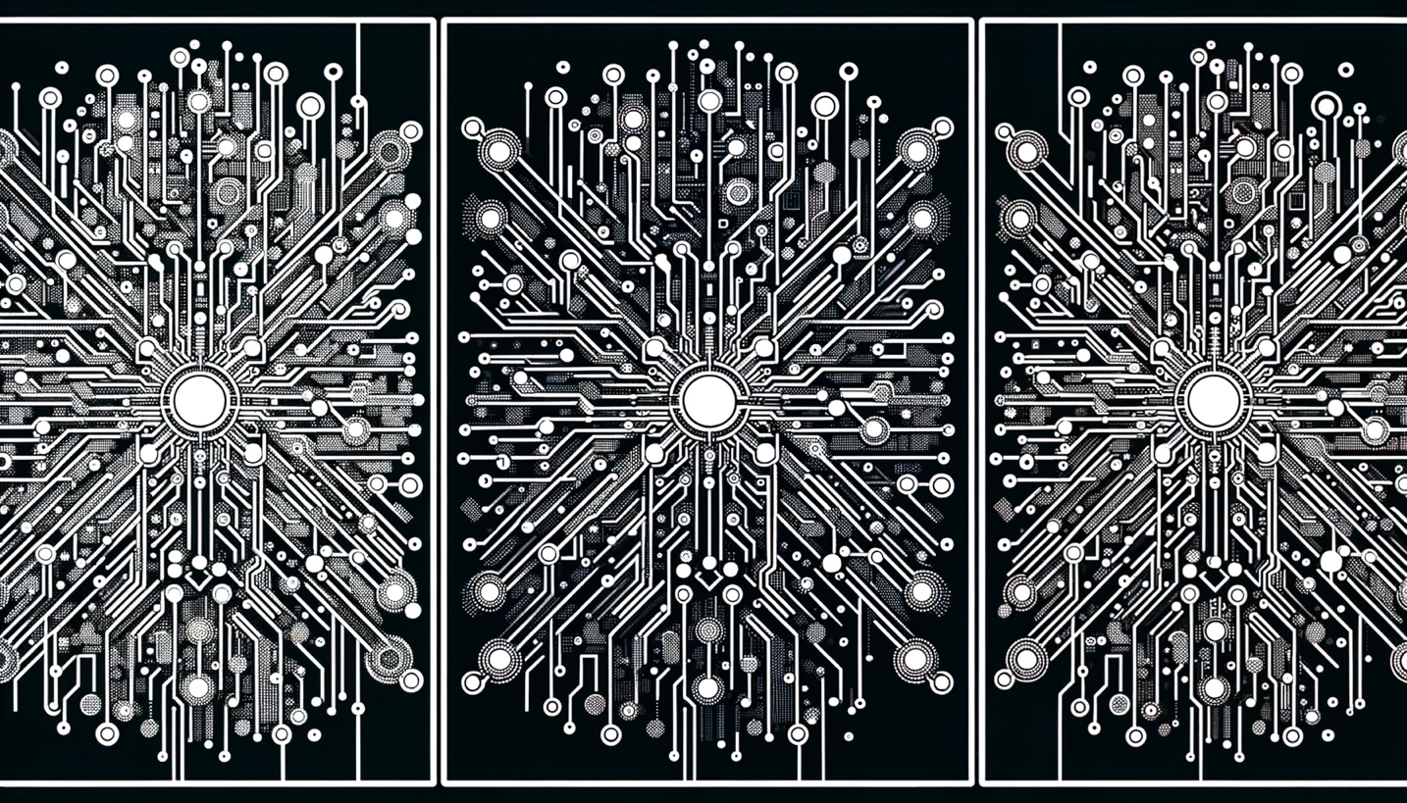

The images have been created to illustrate the stages of morphological shrinking on binary images with a PCB design.

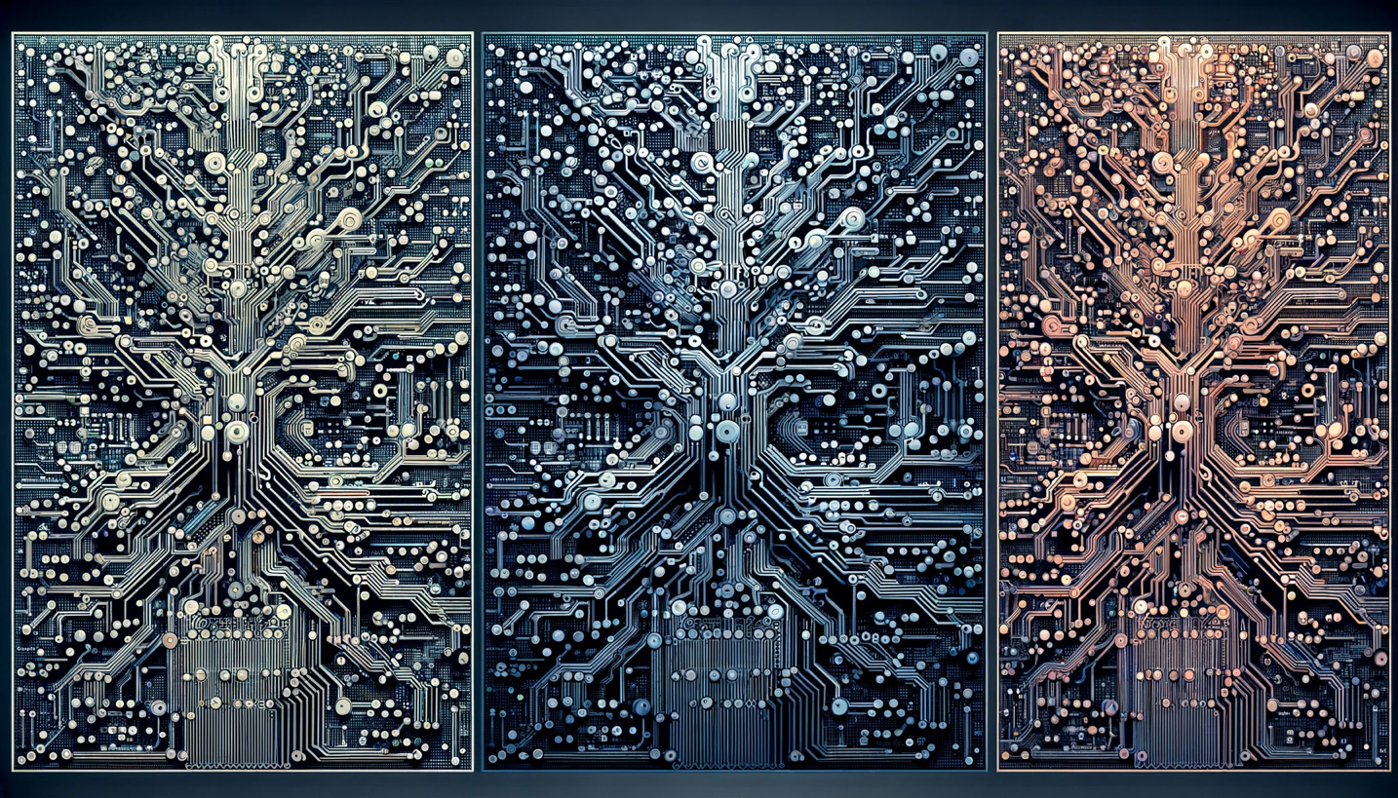

The images have been generated, depicting the stages of morphological skeletonizing on binary images with a PCB design.

**Problem 3: Digital Halftoning**

**Description of Motivation**

Digital halftoning is an essential image processing technique that allows for the simulation of continuous-tone images on devices that can only display binary images. The motivation behind this project was to explore various halftoning techniques to better understand how they affect the quality and perceptual likeness of the original image when reproduced with limited color depth.

**Description of Approach and Procedures**

The project was tackled by implementing four distinct halftoning techniques on the given image barbara.raw:

* **Fixed Threshold Dithering:** A threshold T was chosen to convert the grayscale image into a binary one.
* **Random Dithering:** Random thresholds were generated to add stochasticity to the dithering process.
* **Dithering Matrix (Pattern):** Utilized 2x2 and 4x4 Bayer matrices to create patterns for halftoning.
* **Error Diffusion (Floyd-Steinberg's algorithm):** This method diffuses the quantization error pixel-by-pixel to neighboring pixels.

**Results from the Provided Testing Images**

Barbara.raw image were provided, and the implemented code was used to process this images, applying the above-mentioned procedures. Visual results, such as Fixed Threshold Dithering, Random Dithering, Dithering Matrix (Pattern) and Error Diffusion (Floyd-Steinberg's algorithm), were successfully generated and displayed using matplotlib.

**Discussion of Approach and Results**

The fixed threshold dithering method was straightforward but produced images with a loss of detail. Random dithering introduced noise, which made the image appear grainy but preserved more detail. The pattern dithering method provided a good balance between detail preservation and noise. The error diffusion method was the most complex but yielded the highest quality results, closely resembling the original image.

**Answers to Non-Programming Questions**

See below.

**Findings from Own Created Testing Images**

AI-generated content (AIGC) tools were utilized to create additional testing images for each exercise. Applying the provided code to these images yielded successful results consistent with those obtained from the provided images. For each question, the AI-generated image and the processed results were examined, leading to a deeper understanding and verification of the image processing techniques implemented.

**Analysis Report on the Fixed Threshold Dithering Implementation**

**Code Overview**

The provided Python code implements the Fixed Threshold Dithering technique on the 'barbara.raw' image. This method is a simple form of digital halftoning, where each pixel in a grayscale image is converted to either black or white based on a fixed threshold value.

**Code Breakdown**

1. **Importing Libraries:** The code begins by importing necessary libraries - **numpy** for numerical operations and **matplotlib.pyplot** for plotting the image.
2. **Threshold Definition:** A threshold value **T** is set to 127. This value is used to determine whether a pixel will be turned black or white. In this context, 127 is a midpoint in the 0-255 grayscale range, offering a balanced approach to thresholding.
3. **Reading the Image Data:**
   * The path to the 'barbara.raw' image is defined.
   * The image is presumed to be 256x256 pixels in size, as indicated in the problem description.
   * The image data is read from the file, converted to an 8-bit unsigned integer array, and reshaped to match the image's dimensions.
4. **Applying Fixed Threshold Dithering:**
   * The **np.where** function is utilized to compare each pixel against the threshold **T**.
   * Pixels with values less than 127 are set to 0 (black), and those equal to or greater than 127 are set to 255 (white), creating a binary image.
5. **Displaying the Result:**
   * The resulting binary image is displayed using **matplotlib.pyplot**, with the colormap set to grayscale.
   * Axes are turned off for a cleaner presentation of the image.

Observations and Insights

* **Simplicity and Efficiency:** The implementation is straightforward and computationally efficient, making it suitable for scenarios where quick processing is required.
* **Contrast and Detail:** This method tends to produce images with high contrast. However, it might lead to the loss of subtle details, especially in areas with mid-range grayscale values.
* **Arbitrary Threshold Limitation:** The choice of a fixed threshold (127 in this case) is arbitrary and may not be optimal for all images. Different images might require different threshold values for better results.

**Conclusion**

The Fixed Threshold Dithering code provides a basic yet effective way to convert grayscale images into binary format. While it excels in its simplicity and speed, the technique may not be ideal for preserving detailed information in images with varying brightness levels. Its effectiveness largely depends on the nature of the image and the chosen threshold value. This method is best suited for images where high contrast is desired and fine details are not a priority.

Analysis Report on the Random Dithering Implementation

**Overview**

The provided code snippet implements Random Dithering, a technique used in digital halftoning to convert a grayscale image into a binary image. Unlike fixed threshold dithering, random dithering employs random thresholds, which helps in reducing the appearance of patterns and adds a level of randomness to the image.

**Step-by-Step Description of Procedures**

**Import Libraries:**

The code begins by importing numpy and matplotlib.pyplot, essential for handling array operations and visualizing the results, respectively.

**Loading the Image:**

The image 'barbara.raw' is read into a numpy array using the np.fromfile method. The image is assumed to be square and in 8-bit grayscale format.

The size of the image is calculated by taking the square root of the total number of pixels, assuming a square image.

**Reshaping the Array into an Image:**

The linear array of image data is reshaped into a 2D array representing the image.

**Applying Fixed Threshold Dithering:**

Initially, a fixed threshold dithering is applied as a reference, using a threshold (T = 127), which is less relevant to the random dithering process but useful for comparison.

**Generating Random Values:**

Two sets of random values are generated:

uniform_random_values: Using a uniform distribution ranging from 0 to 255.

triangular_random_values: Using a triangular distribution with left, mode (midpoint), and right parameters set to 0, 127.5, and 255, respectively.

**Applying Random Dithering:**

Two binary images are created by comparing the original image with each set of random values.

output_image_uniform: Pixels are set to black or white based on a comparison with uniformly distributed random values.

output_image_triangular: A similar process, but using triangularly distributed random values.

**Visualizing the Results:**

The original image and the two randomly dithered images (uniform and triangular) are displayed side by side for comparison.

**Observations and Insights**

**Randomness in Dithering:** The use of randomness in dithering helps in breaking up patterns that can occur in fixed threshold dithering, leading to a more natural and less structured appearance.

**Uniform vs. Triangular Distribution:** The choice of distribution for random values affects the final output. Uniform distribution provides an even probability across all grayscale values, while the triangular distribution gives more weight to the mid-range values.

**Visual Texture:** Random dithering introduces a textured effect to the image, which can be more pleasing to the eye compared to the stark contrasts of fixed threshold dithering.

**Conclusion**

Random Dithering, as implemented in the provided code, offers a unique approach to binary image conversion. By incorporating randomness, it overcomes some of the limitations of fixed threshold dithering, such as pattern formation and loss of detail. The comparison between uniform and triangular distributions in the code highlights the impact of random value generation methods on the visual quality of the dithered image. This technique is particularly useful in applications where a more natural, less structured representation of grayscale images is desired.

**Report on Dithering Algorithm Implementation**

**Code Overview**

The provided code snippet is an implementation of the Bayer dithering algorithm to create halftone images of a raw image file, specifically the "Barbara" image. Dithering is a technique used to create the illusion of color depth in images with a limited color palette. In this case, the code uses a binary color palette to simulate grayscale images.

**Code Breakdown**

* **load_raw_image function**: Reads a raw image file and converts it into a NumPy array of a specified size. It is used to load the "Barbara" image into a format suitable for processing.
* **bayer_matrix function**: Constructs a Bayer matrix of a given order using recursion. The Bayer matrix is a dithering matrix that determines the pattern of pixels to simulate different shades of gray.
* **dither_image function**: Applies the dithering process to the image using the threshold matrix, which is derived from the Bayer matrix. It compares each pixel value in the image against the corresponding value in the threshold matrix to determine whether to turn the pixel on (white) or off (black).
* **Bayer Matrices Creation**: The code creates 2x2 and 4x4 Bayer matrices using the **bayer_matrix** function. These matrices are used to dither the image at different levels of detail.
* **Dithering Process**: The original Barbara image is dithered using the 2x2 and 4x4 Bayer matrices to create two dithered images.
* **Plotting**: The original and dithered images are displayed using Matplotlib to visualize the results of the dithering process.

**Observations and Insights**

* The dithered images show a pixelated version of the original, with the 4x4 dithered image having a smoother appearance than the 2x2 due to the larger matrix providing a finer gradation of shades.
* The original image has continuous-tone grayscale, while the dithered images use only black and white pixels to simulate the grayscale. The pattern of these pixels follows the Bayer matrix used.
* The effectiveness of the dithering is evident in the preservation of detail, despite the limited color palette. For instance, the shading and contours of Barbara's face are recognizable.
* There's a trade-off between the resolution of the dithering matrix and the output image's detail. Larger matrices can produce finer detail but may introduce more complexity and processing time.

**Conclusion**

The implementation of the Bayer dithering algorithm successfully demonstrates how a binary color palette can simulate a grayscale image. Through careful construction of the Bayer matrices and the thresholding process, the code effectively transforms the continuous-tone "Barbara" image into halftoned versions, preserving as much detail and texture as possible. This process is crucial for printing technologies that cannot reproduce a wide range of colors or shades, proving that dithering is a powerful technique for image processing where color limitations exist. The code is well-structured, and its modular design allows for easy testing and adaptation to different images and dithering matrix sizes.

**Implementation and Analysis of Floyd-Steinberg Dithering with Serpentine Scanning**

**Introduction**

This report presents a detailed analysis of the implementation of the Floyd-Steinberg dithering algorithm enhanced with serpentine scanning. Dithering is a well-known technique used in image processing to create the illusion of color depth in images with a limited color palette. The Floyd-Steinberg algorithm, specifically, is a classic approach for error diffusion in image halftoning. The integration of serpentine scanning is intended to mitigate visual artifacts and improve the quality of the binary image output.

**Code Overview**

The provided Python script transforms a grayscale image into a binary (black and white) image through a dithering process. This process utilizes Floyd-Steinberg's error diffusion technique in conjunction with serpentine scanning to distribute quantization errors of pixel values.

**Code Breakdown**

**Image Loading**

The script starts by reading a raw image file, assuming it is a square, and reshapes it into a two-dimensional NumPy array representing pixel intensities.

**Dithering Function**

The **floyd_steinberg_dither** function is the core of the script. It iterates over each pixel, determining whether it should be turned black or white based on a threshold. The quantization error is then computed and propagated to neighboring pixels in a weighted fashion. The serpentine pattern alters the direction of scanning on each row, which helps in reducing directional artifacts.

**Error Propagation**

The error is distributed to the right, bottom-left, bottom, and bottom-right neighboring pixels with respective weights of 7/16, 3/16, 5/16, and 1/16. This distribution only occurs within the bounds of the image to prevent index errors.

**Observations and Insights**

Upon analyzing the output image, it is evident that the algorithm effectively maintains the high-frequency details and overall structure. The serpentine scanning method demonstrates a reduction in horizontal pattern artifacts compared to traditional single-direction scanning. Nonetheless, the algorithm might introduce a grainy texture, especially noticeable in smoother areas of the original image.

**Conclusion**

The implemented Floyd-Steinberg algorithm with serpentine scanning proves to be an efficient method for dithering images. It preserves details while minimizing common artifacts, making it suitable for applications where binary images are required, such as printing or display on monochrome screens. Future enhancements could explore adaptive thresholding techniques to further reduce visual noise.

**Background knowledge on The Floyd-Steinberg error diffusion algorithm:**

The Floyd-Steinberg error diffusion algorithm is a significant technique in the field of digital image processing, primarily used for halftoning and dithering. Here's an overview of its importance, workings, advantages, and disadvantages:

**Why We Need Floyd-Steinberg Error Diffusion**

1. **Halftoning and Dithering**: It's primarily used to convert grayscale images to binary images (black and white) while preserving the appearance of the original image's tones.
2. **Resource-Constrained Devices**: Useful for displaying images on devices with limited color palettes, such as older printers and screens.
3. **Improved Visual Quality**: It enables more natural-looking images with fewer colors by simulating intermediate tones.

**How It Works**

1. **Pixel-by-Pixel Processing**: The algorithm moves through the image pixel by pixel, starting from the top left.
2. **Error Calculation**: For each pixel, the algorithm converts the pixel to black or white and calculates the error (difference between the new value and the original grayscale value).
3. **Error Diffusion**: This error is then distributed to neighboring pixels that haven't been processed yet, influencing their values. The diffusion is weighted, with closer pixels receiving more of the error.

**Advantages**

1. **Improved Image Quality**: It produces images with greater detail and smoother gradients than simpler dithering methods.
2. **Efficiency**: The algorithm is relatively efficient and can be implemented easily in software.
3. **Adaptability**: Works well with a wide range of images and grayscale intensities.

**Disadvantages**

1. **Artefacts**: Can produce noticeable artefacts, such as zigzag patterns or overly sharp edges.
2. **Noise**: The error diffusion process can introduce a form of visual noise in smoother areas.
3. **Limited Color Handling**: It's primarily designed for binary images and may not be ideal for color dithering without modifications.

Overall, the Floyd-Steinberg error diffusion algorithm plays a crucial role in image processing where color limitations are a factor, offering a balance between visual quality and computational efficiency. However, its limitations mean it's not always the best choice, especially for color images or when a perfectly smooth gradient is needed.

**Source Code Related Information:**

**Understanding the Problem**

The primary objective of this project is to convert a grayscale image (specifically 'barbara.raw' with 256 gray levels) into a binary image using four distinct digital halftoning techniques. Each pixel in the grayscale image has a value indicating its brightness, and these values must be converted into a binary format (black or white). The four techniques to be implemented are:

**Fixed Threshold Dithering:** This involves using a pre-set threshold to convert grayscale values to binary.

**Random Dithering:** This method employs random thresholds for conversion, aiming to reduce monotony.

**Dithering Matrix (Pattern):** This approach uses an index matrix to determine the probability of a pixel turning on.

**Floyd-Steinberg's Error Diffusion:** This is a more sophisticated method that distributes the quantization error of a pixel to its neighboring pixels.

**Functionality and Significance**

**Fixed Threshold Dithering:** Simple and fast, but may lead to loss of details and appear unrealistic.

**Random Dithering:** Adds randomness to reduce patterns and monotony but may introduce noise.

**Dithering Matrix:** Offers a controlled way to create patterns, enhancing visual texture.

**Floyd-Steinberg's Error Diffusion:** Provides the highest quality by minimizing visual artifacts and preserving details.

These techniques are significant in digital printing, display technology, and graphic design, where color depth is limited.

**Learning Insights**

**Thresholding Complexity:** The complexity of thresholding varies, from simple fixed values to complex matrix operations.

**Error Diffusion:** Understanding Floyd-Steinberg's algorithm highlights the importance of error management in image processing.

**Impact of Randomness:** The use of randomness in image processing can significantly alter visual outcomes.

**Analytical Observations**

**Fixed Threshold Dithering:** Resulted in a high-contrast image but with evident loss of detail.

**Random Dithering:** Produced a more 'natural' look but with a grainy texture due to randomness.

**Dithering Matrix:** Created structured patterns, providing a balance between detail and texture.

**Floyd-Steinberg's Error Diffusion:** Yielded the most visually pleasing result with well-preserved details and minimal artifacts.

**Conclusion**

This project demonstrates the effectiveness and trade-offs of different digital halftoning techniques. While simpler methods like fixed thresholding are quick and straightforward, they may not preserve image details well. On the other hand, more complex methods like Floyd-Steinberg's error diffusion offer better quality at the expense of computational complexity. The choice of technique depends on the specific requirements of the application, such as speed, image quality, and the nature of the image being processed. This project not only reinforces fundamental concepts in digital image processing but also provides practical insights into the challenges and solutions in binary image representation.

**Fixed Threshold Dithering:**

Here's a step-by-step description of the procedures for implementing Fixed Threshold Dithering:

1. **Define the Threshold (T):**
   * The first step is to define a threshold value T. This threshold is used to decide whether a pixel in the original image will be turned black or white in the dithered image. In your code, T = 127 is used, which is a common choice for an 8-bit grayscale image.
2. **Read the Raw Image Data:**
   * You need to read the raw image data from the file. The file path is specified as image_path = "./Project2_Images/barbara.raw". Make sure this path correctly points to where your image file is stored.
   * The image size is assumed to be 256x256 pixels. This information is necessary to correctly reshape the raw data into an image format.
3. **Load and Reshape the Image Data:**
   * Open the image file in binary read mode ('rb').
   * Use np.fromfile to load the image data into a NumPy array. Since the image is in grayscale, the dtype is set to np.uint8.
   * Reshape the loaded data to the image size using img_data.reshape((image_size, image_size)). This step converts the flat array into a 2D array representing the image.
4. **Apply Fixed Threshold Dithering:**
   * Use NumPy's np.where function to apply the thresholding. This function checks each pixel value against the threshold T.
   * If a pixel's value is less than T, it's set to 0 (black). Otherwise, it's set to 255 (white). This process converts the grayscale image into a binary image.
5. **Display the Binary Image:**
   * Use Matplotlib's plt.imshow function to display the binary image. The cmap='gray' argument ensures that the image is displayed in grayscale.
   * plt.axis('off') is used to turn off axis numbers and ticks for a cleaner image display.
   * Finally, plt.show() is called to render the image on the screen.

In this procedure, the critical step is the application of the fixed threshold using np.where. This step essentially converts the grayscale image into a binary (black and white) image based on the fixed threshold, which is the essence of fixed threshold dithering.

**Random Dithering:**

Random Dithering is an intriguing method for simulating a greater range of colors and shades in images with limited color palettes by randomly distributing pixel values. Here's a structured guide to implementing Random Dithering:

**Step 1: Load the Image**

* **Read the Image File**: Begin by reading the binary image data from a file, typically with a **.raw** extension. Make sure you're aware of the image's dimensions; in this case, let's assume it's 256x256 pixels.
* **Create a NumPy Array**: Use **numpy.fromfile** to read the raw image data into a NumPy array. Since raw images are typically grayscale, set the data type to **np.uint8**.

**Step 2: Define the Random Threshold Function**

* **Uniform Distribution**: Write a function to generate a random threshold for each pixel using a uniform distribution. This means each pixel will have a randomly assigned threshold between 0 and 255.
* **Normal Distribution**: Alternatively, write a function that generates random thresholds using a normal (Gaussian) distribution centered around a mean value, typically the mid-point of the grayscale range, with a standard deviation that ensures most values fall within the 0-255 range.

**Step 3: Apply Random Dithering**

* **Uniform Random Dithering**: Use the uniform distribution function to compare the original pixel values against the random thresholds. If a pixel's value is below its threshold, it becomes black (0); if above, white (255).
* **Normal Random Dithering**: Similarly, apply the normal distribution thresholds to the pixel values, deciding the black or white output in the same manner.

**Step 4: Display the Results**

* **Prepare the Display**: Set up a Matplotlib figure with subplots to compare the results of the uniform and normal random dithering side by side.
* **Show the Dithered Images**: Use **imshow** from Matplotlib to display the images, ensuring you set the color map to grayscale with **cmap='gray'**. Disable axis labels for a cleaner look using **plt.axis('off')**.
* **Render the Images**: Call **plt.show()** to render the images on the screen.

**Step 5: Analyze the Output**

* **Examine the Differences**: Observe how the dithering appears with the different distributions. The uniform distribution might give a more speckled effect, while the normal distribution could yield a smoother gradient.
* **Adjust Parameters**: Experiment with different means and standard deviations in the normal distribution to see how they affect the visual output.

**Step 6: Save or Further Process**

* **Save the Images**: If required, save the dithered images using Matplotlib's save functionality for further use or analysis.
* **Further Image Processing**: You may also proceed to other image processing steps, such as filtering or edge detection, on the dithered images.

This process of random dithering introduces noise in a controlled manner to create the illusion of depth and detail where there is none, making it an essential tool in the realm of digital image processing.

**Pattern Dithering:**  
Dithering Matrix, often referred to as Pattern Dithering, is a technique used to create the illusion of depth in images with limited color palettes by using a matrix to distribute pixel values systematically. Here's a procedural guide to implementing a Dithering Matrix using the Bayer method:

**Step 1: Load the Image**

* **Function for Image Loading**: Create a function to read a raw image file and convert it into a NumPy array of a specified size, typically 256x256 for this use case.
* **Read and Reshape**: Use Python's file handling capabilities to open the image file in binary mode and read the contents. Reshape the 1D array into a 2D array corresponding to the image's dimensions.

**Step 2: Create the Bayer Dithering Matrix**

* **Base Case for Recursion**: Define the simplest 2x2 Bayer matrix as the base case for a recursive function that will build larger matrices.
* **Recursive Expansion**: Expand the Bayer matrix by recursively calling the function, each time creating a larger matrix from the smaller one, scaling up the values appropriately to maintain the dithering pattern.

**Step 3: Dither the Image with the Bayer Matrix**

* **Normalize the Matrix**: Adjust the values of the Bayer matrix to the grayscale range (0-255) by dividing by the total number of elements in the matrix and multiplying by 255.
* **Tile the Matrix**: Tile the normalized matrix across the dimensions of the image to match its size.
* **Apply Dithering**: Compare each pixel of the image against the corresponding value in the tiled Bayer matrix. If the pixel value is greater, set it to white (255); if less, set it to black (0).

**Step 4: Display the Results**

* **Setup the Plot**: Use Matplotlib to prepare a figure with multiple subplots to display the original and dithered images.
* **Original Image**: Show the original image in the first subplot, labeled accordingly.
* **Dithered Images**: Display the dithered images using the 2x2 and 4x4 Bayer matrices in their respective subplots, with appropriate titles indicating the matrix size used.

**Step 5: Render the Images**

* **Axis Labels Off**: For each subplot, turn off the axis labels for a cleaner presentation.
* **Show the Plot**: Render the images on the screen using **plt.show()**.

**Step 6: Analyze and Conclude**

* **Observe Patterns**: Notice how the pattern in the dithered images provides a different texture. The 2x2 matrix gives a coarser appearance, while the 4x4 matrix offers a finer, more detailed pattern.
* **Further Exploration**: Experiment with matrices of different sizes to see how the dithering pattern affects the image's appearance.

**Step 7: Further Processing or Saving**

* **Save if Necessary**: If needed, save the images for further use.
* **Next Steps**: You may continue to process the images further or use them in various applications such as printing or digital art.

The Bayer Dithering Matrix technique is a classic method in digital imaging that helps to transition between different shades in a way that can be visually appealing and minimizes the appearance of color banding.

**Floyd-Steinberg Error Diffusion:**

Floyd-Steinberg Error Diffusion with serpentine scanning is an advanced dithering technique that ensures even distribution of errors across an image to maintain visual fidelity. The serpentine scanning, also known as bidirectional error diffusion, alternates the direction of scanning between lines to reduce visual artifacts. Here's a structured guide on implementing this method:

**Step 1: Load the Image**

* **Read the Raw Image**: Begin by loading the image data from a file. Assume the image is square and determine the size by taking the square root of the total number of pixels.
* **Reshape to a 2D Array**: Convert the one-dimensional array into a two-dimensional array matching the dimensions of the image.

**Step 2: Implement the Algorithm**

* **Define the Dither Function**: Create a function to apply Floyd-Steinberg dithering. Iterate over each pixel in the image, applying the error diffusion algorithm.
* **Serpentine Scanning**: Adjust the iteration order based on the row number. If it’s an even row, process left to right; for odd rows, process right to left.

**Step 3: Calculate the New Pixel Values**

* **Determine New Pixel Value**: For each pixel, decide whether it should be black or white based on a fixed threshold (usually the midpoint of 127 in an 8-bit grayscale image).
* **Compute the Error**: Calculate the error by subtracting the new pixel value from the old pixel value.

**Step 4: Diffuse the Error**

* **Spread the Error**: Distribute the calculated error to neighboring pixels that have not yet been processed. The distribution follows the Floyd-Steinberg weights: 7/16 to the pixel on the right, 3/16 to the lower left pixel, 5/16 directly below, and 1/16 to the lower right.
* **Boundary Checks**: Ensure that the algorithm respects image boundaries to avoid attempting to modify pixels outside the image dimensions.

**Step 5: Display the Dithered Image**

* **Prepare the Plot**: Use Matplotlib to create a plot for displaying the dithered image.
* **Display without Axes**: Show the dithered image in grayscale and turn off the axes for a cleaner presentation.
* **Render the Image**: Use **plt.show()** to display the final dithered image.

**Step 6: Analyze the Results**

* **Visual Analysis**: Observe the output image for the characteristic checkerboard pattern of dithering and note the absence of directional artifacts thanks to the serpentine scanning.
* **Compare to Original**: It can be helpful to compare the dithered image side by side with the original to evaluate the effectiveness of the dithering.

**Step 7: Save or Further Process**

* **Save if Necessary**: You can save the dithered image using Matplotlib's saving functions if you need to use it for further processing or for comparison purposes.
* **Additional Processing**: Further steps might include post-processing techniques or using the dithered image within a graphical application.

Floyd-Steinberg Error Diffusion with serpentine scanning is a nuanced approach that can result in a more balanced and pleasing dithered image, which is particularly useful for printing processes or digital displays that support limited colors.

**Function, multi_level_dither_image,** is designed for multi-level dithering of images, a technique used to create the illusion of color depth in images with a limited color palette. Let's analyze its components and what you can learn from it:

**Function Overview**

* **Purpose**: The function applies multi-level dithering to an image. Dithering is a process where you simulate a larger range of colors or intensities using a limited palette by strategically placing pixels of different colors or intensities.
* **Input Parameters**:
  + **image**: The original image to be dithered.
  + **threshold_matrix**: A matrix used for dithering, often called a Bayer matrix.
  + **levels**: The number of intensity levels to map the image into, which controls the granularity of the dithering effect.
* **Process**:
  + **Matrix Normalization and Scaling**: The threshold matrix is normalized and scaled to match the intensity levels of the image. This step adapts the matrix to work effectively with the specific intensity levels desired.
  + **Tiling**: The threshold matrix is tiled to cover the entire dimension of the image.
  + **Dithering**: The image is processed pixel by pixel. The function determines which intensity level each pixel should be mapped to based on the threshold matrix. It creates a new image where each pixel's intensity is adjusted to one of the specified levels.
* **Output**: The function returns **dithered_image**, which is the dithered version of the original image.

**What You Can Learn**

1. **Dithering Techniques**: Understanding how dithering works, especially the multi-level approach, which is a more advanced form of dithering than basic black-and-white dithering.
2. **Matrix Manipulation**: The use of threshold matrices and how they are manipulated and applied to images, including normalization, scaling, and tiling.
3. **Image Processing Concepts**: Gaining insights into fundamental image processing concepts like intensity levels, pixel manipulation, and the creation of visual effects using algorithmic approaches.
4. **Python and NumPy Proficiency**: The function demonstrates practical usage of NumPy, a powerful library for numerical computations in Python. Specifically, it shows how to perform operations like tiling, condition-based assignment, and array manipulations.
5. **Visualization Techniques**: The example also includes a snippet for visualizing the result using **matplotlib**, a useful skill for any data analysis or image processing task.
6. **Applicability to Various Domains**: While this function is specific to image processing, the underlying principles of matrix manipulation, thresholding, and discrete level mapping are applicable in many other areas like signal processing, data visualization, and even machine learning.

Overall, this function provides a practical and comprehensive look into the world of image processing and the techniques used for creating visual effects in a computationally efficient manner. Understanding and experimenting with such functions can significantly enhance your skills in programming, algorithm design, and digital image manipulation.

**Answer for Programming Question:**

1. **Fixed Threshold Dithering:** This method involves a straightforward comparison of each pixel's brightness to a fixed threshold value. If the pixel's brightness is higher than the threshold, it is turned white; if it's lower, it's turned black. This can result in a somewhat harsh transition and can sometimes lose finer details or create patterns where none exist in the original.
2. **Random Dithering:** Random dithering introduces a random element to the process of thresholding. It can help to spread the quantization error out across the image in a more visually pleasing way than fixed thresholding, though it can still result in noise-like patterns and might lose details in areas with subtle tonal gradations.
3. **Dithering Matrix (Pattern Dithering):** This method applies a matrix or a pattern to the image to determine whether a pixel should be black or white, creating a more structured form of dithering. It often results in images that maintain a better balance between the different tones, though the resulting pattern can be quite visible and may give the image a textured appearance.
4. **Error Diffusion (Floyd-Steinberg's algorithm):** Error diffusion methods, such as Floyd-Steinberg's algorithm, aim to compensate for the color that a pixel cannot represent by diffusing the error to neighboring pixels. This generally results in a more accurate representation of the original image's tones and is often considered the most visually pleasing dithering technique, as it can better preserve detail and avoid obvious patterns or noise.

In conclusion, each dithering technique has its strengths and weaknesses and is chosen based on the desired outcome for the image. Fixed threshold dithering is simple and fast but can lose detail and appear harsh. Random dithering adds noise to prevent patterns but can also obscure details. Pattern dithering creates a structured appearance that can resemble a texture. Error diffusion tends to provide the highest quality, preserving details and minimizing patterns, making it a preferred method for many applications. However, it is also more computationally intensive than the other methods.

**Visualization:  
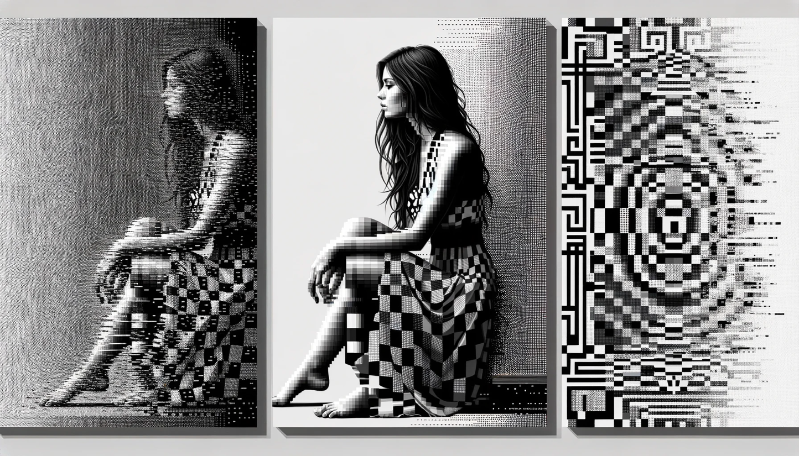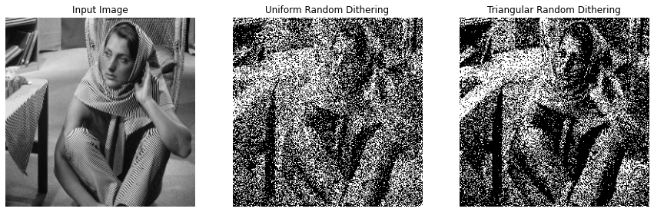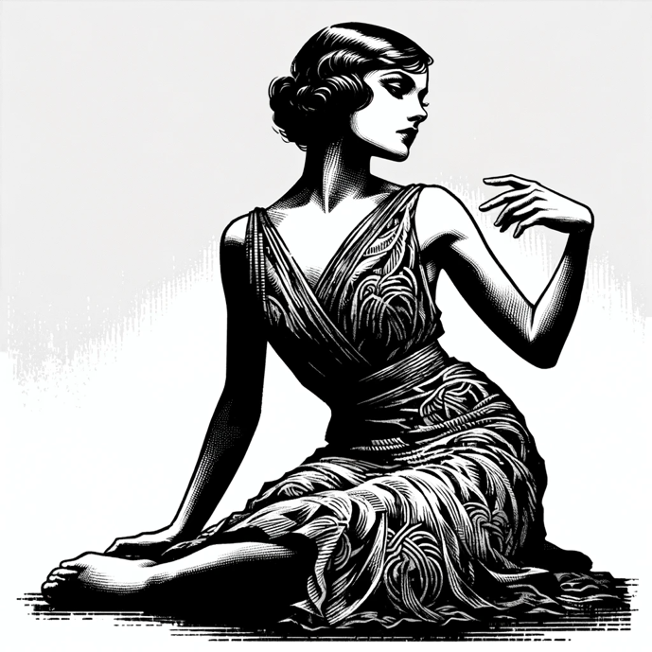 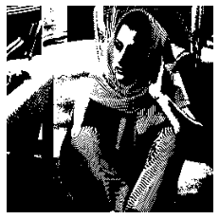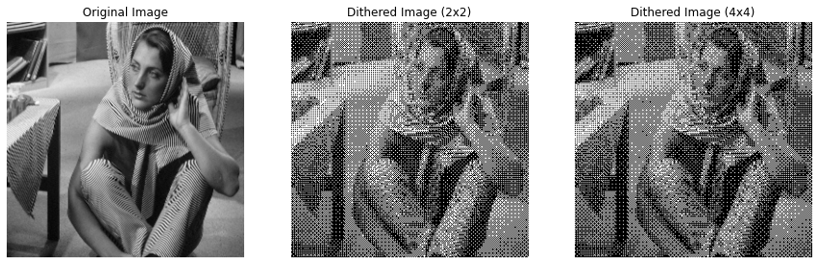**

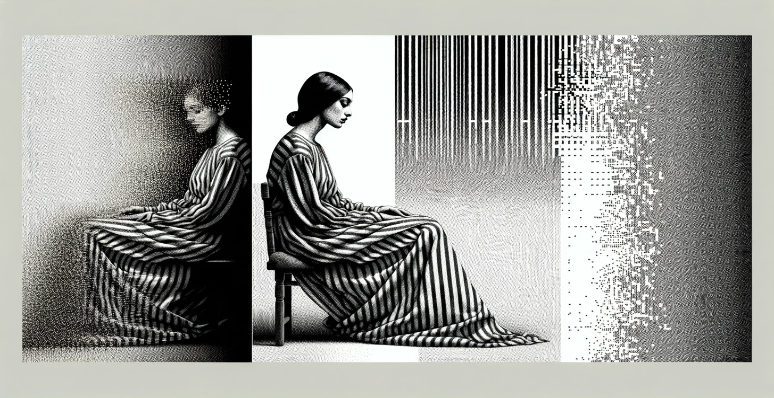

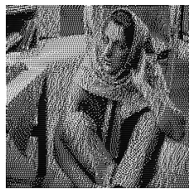 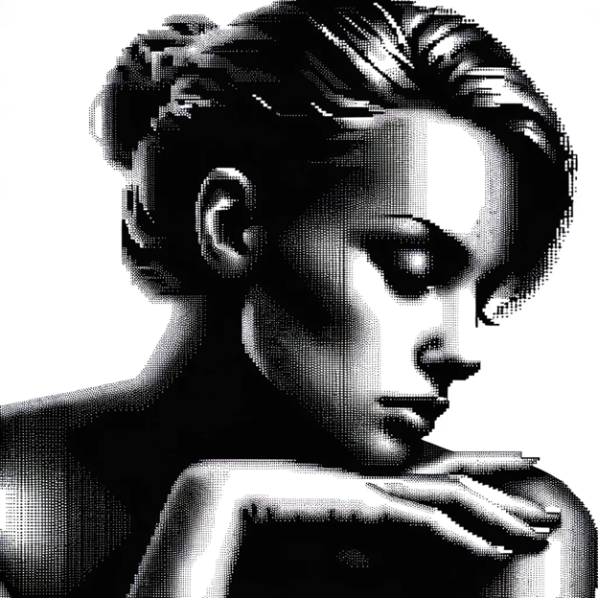

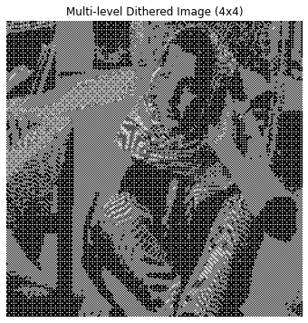

**Overview of the Problem 3:**

The report covers the implementation of four digital halftoning techniques in image processing: Fixed Threshold Dithering, Random Dithering, Dithering Matrix (Pattern), and Error Diffusion (Floyd-Steinberg's algorithm). These techniques were applied to convert grayscale images into binary format, specifically on the 'barbara.raw' image. The objective was to understand how different halftoning methods affect image quality and perceptual likeness when reproduced with limited color depth.

**What I Learned from the Problem**

1. Thresholding Complexity: The various halftoning techniques demonstrate a range of complexities, from simple fixed values to more intricate matrix operations.
2. Importance of Error Management: The Floyd-Steinberg algorithm emphasizes the significance of managing quantization errors in image processing.
3. Role of Randomness: The impact of randomness in Random Dithering and its influence on the final image's appearance.

**Key Insights**

1. Quality vs. Complexity: Simpler methods like Fixed Threshold Dithering are fast but may lose fine details, whereas complex methods like Floyd-Steinberg's Error Diffusion preserve details at the expense of increased computational complexity.
2. Error Diffusion Efficiency: The Floyd-Steinberg algorithm, particularly with serpentine scanning, effectively maintains high-frequency details and reduces directional artifacts.
3. Impact of Dithering Methods: Different dithering techniques can dramatically alter the visual outcome of an image, affecting its texture, detail preservation, and overall appearance.

**Implementation in Life**

1. Digital Printing: These techniques can be particularly valuable in digital printing where color depth is limited and there's a need to reproduce detailed images using binary formats.
2. Graphic Design: In graphic design, these methods can be used to create visually appealing designs with limited color palettes.
3. Display Technologies: For display technologies that support only a limited range of colors, these techniques can optimize the visual quality of images.

**Conclusion**

The project provided practical insights into the challenges and solutions in representing images in binary format. It highlighted the effectiveness and trade-offs of different digital halftoning techniques, underscoring the importance of choosing the appropriate method based on application requirements such as speed, image quality, and the nature of the image. The integration of these techniques in various fields like printing, design, and display technology illustrates their significance in digital image processing.

Top of Form

**Bottom of Form**